KD RESET GUIDE
After building the Desk for the first time, the “Initialisation” will need to be carried out. In some rare occasions, the system can lose a reference point and stop working, carrying out this “initialisation” will also resolve this.
Initialisation Procedure
**IMPORTANT** REMOVE ALL OBSTRUCTIONS FROM UNDER THE DESK eg, PEDS, CHAIRS ETC**
Failure to do this could cause irreparable damage to the actuators if a collision occurs, and will VOID ALL WARRANTY
For the Collision Detection to work the control box must be Securely Fixed to the under side of the desktop!
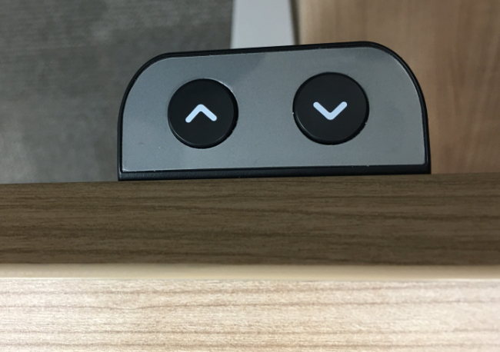

PRESS AND HOLD THE & BUTTONS SIMULTAINIOUSLY FOR MORE THAN 3 SECONDS

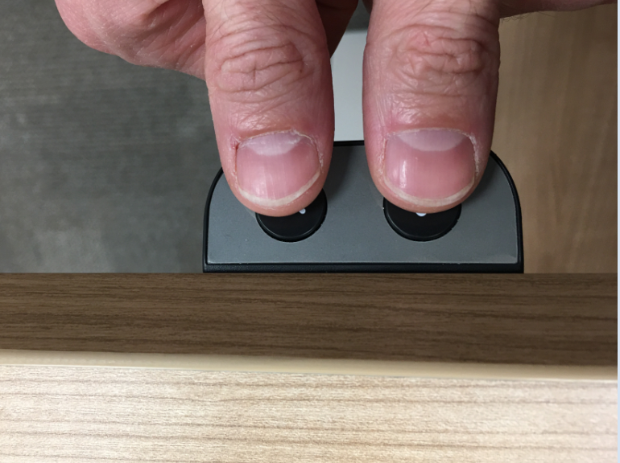

Once the Desk begins to move keep the buttons pressed until the desk reaches the bottom of its stroke. The actuators will then rebound around 2-3mm. The Initialisation is now complete. The Desk should now work as expected.

