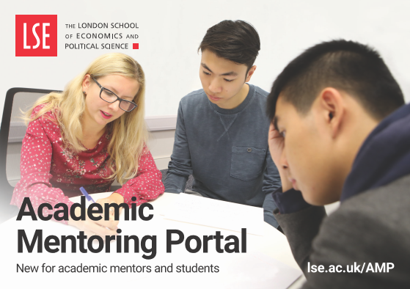
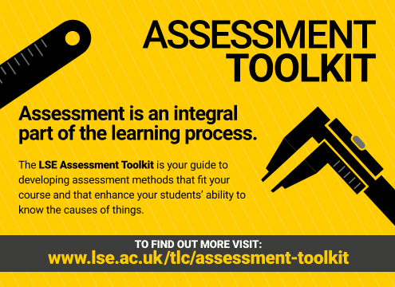

LSE Education Symposium
2 May 2019
Hosted by LSE Teaching and Learning Centre

Welcome to the LSE Education Symposium 2019. The Symposium this year is a multi-venue event. Staff speakers in the morning at The Lincoln Centre and in 32 Lincolns Inn Fields discuss excellence and innovation in their practice, on the particular themes of inclusivity and research-informed teaching.
In the afternoon, Change Makers student researchers share their projects and findings both at The Lincoln Centre and in a ‘marketplace of ideas’ in the Parish Hall. Change Makers is a joint LSE SU/LSE initiative. Further staff speakers also share their practice.
The day concludes with the keynote at The Lincoln Centre by the Pro-Director Education, Professor Dilly Fung.
Morning sessions
 | The Lincoln Centre,  18 Lincoln's Inn Fields | 32 Lincolns Inn Fields  32L.LG.14
11:00 | Staff speakers  Using crowdsourcing platforms as learning technology to improve the replicability of psychological science through facilitating cross-cultural group-work research.  Frederic Basso, Psychological and Behavioural Science  Statistics research internships  George Tzougas, Statistics  Chair: Claire Gordon, Teaching and Learning Centre | Staff speakers  Dilemmas of inclusion for teaching Chinese political thought  Leigh Jenco, Government  When it's all just Marmite: Reflections on LL100 Foundational Legal Skills  Sonya Onwu, Law  Chair: Sara Camacho-Felix, Teaching and Learning Centre
12:00 | LUNCH at the Lincoln Centre
e
Afternoon sessions
 | Lincoln Centre, 18 Lincoln's Inn Fields | Parish Hall, PAR.LG.03
12:30 | LSE Director’s welcome from Dame Minouche Shafik  Change Makers presentations  (with introduction from LSESU Education Officer Martha Ojo)  Inclusion Plans for disabled LSE students: what's really happening?  Alison Beck and Amanda Nenzen  Have we been training our class teachers well? An exploration to discover effective training programmes in Economics.  Yi On Ko and Miaomiao Zhang  LSESU Societies: Are they giving students a sense of community?  Mubashshira Rahman  Do I Fit in?: an exploration of the experiences of undergraduate and postgraduate first-generation students at the LSE  Maria Gafforio, Zoi Adrianopoulou and Marie-Isabel Theuwis | Change Makers marketplace  Why is feedback not effective?  Ningyuan Jia  Defining inclusivity  Aathira Kottapurath and Eve Kraicer-Melamed  Community through communication: understanding the formation of identity and community at LSE  Magdalena Parkhurst  Do I fit in?: An exploration of the experiences of undergraduate and postgraduate first-generation students at the LSE  Maria Gafforio, Zoi Adrianopoulou and Marie-Isabel Theuwis  Improving feedback methods on formative and summative assessments  Saskia Straub  Looking into student expectations: research on the divergence of incoming students' expectations and first year Management students' experiences  Richard Einhorn and Leon Feller  LSE’s Ethics Code Strategy for the academic year 2019-20  Georgios Syranidis  Analysing the impact of summative class participation on student engagement and satisfaction  Damian Virchow and Rory Gillis  Volunteering at LSE: Assessing the implications amongst undergraduate students  Zaynab Olyabek
13:35 | BREAK
13:40 | Change Makers presentations  Race-based exclusion, bias, and discrimination: Methods of creating inclusive classrooms  Keeyaa Chaurey  #PartofLSE? An exploration of how postgraduate students from low socioeconomic backgrounds assimilate into the university community  Abby Hennessey, Lara Neervoort and Brian Walker  Different departments but only one LSE - Unifying the student experience  Helena Palma Carvalho  #PartofLSE? The neglect of joint honours students at LSE.  Izzy Colledge and Erica Stanley
14:30 | BREAK
14:45 | Staff speakers  Getting undergraduates to work in teams, on real projects, in real time: the PPE Capstone experience  Patrick Dunleavy, Government  Aiming for published research: the PPE applications course and student journal  Alex Voorhoeve, Philosophy, Logic and Scientific Method  Chair: Lee-Ann Sequeira, Teaching and Learning Centre | Staff speakers  Using online technology to improve students' course experience  Frank Cowell and Kasia Krajniewska, Economics  Training GTAs: PhD students as apprentices  Patrick Wallis, Economic History  Chair: Mark Baltovic, Teaching and Learning Centre
 | BREAK | Evening – LSESU Teaching Excellence Awards ceremony & drinks reception  18:30-20:00 – Saw Swee Hock Basement
16:00 | Keynote address Professor Dilly Fung, Pro-Director Education  Powerful Learning for a Challenging World
17:00 CLOSE OF SYMPOSIUM

