Making teaching materials accessible

The following document has been prepared by the LSE Disability and Mental Health Service (DMHS). The aim is to provide guidance to academic staff on the preparation of their teaching materials with screen-reader accessibility in mind.
How do blind and partially sighted people read?
Blind and partially sighted people read in a variety of ways. On electronic devices, text can be enlarged, software is available to read it aloud with a synthetic voice, or to show it in braille on a refreshable braille display. Electronic documents can thus be read by blind and partially sighted people, though need to be designed with accessibility in mind. Some methods of presenting information result in electronic materials which are unreadable by blind and partially sighted people. Making information accessible need not be more expensive nor complicated; it simply requires some awareness, and a slight adaptation to the way things are prepared and presented.
How do screen-readers work?
For those who cannot read enlarged text, screen-readers such as JAWS are the most common way of accessing written material. They work by converting digital text into synthesised speech, or a refreshable braille display (less commonly used). There are two basic principles which need to be understood when designing electronic documents to be accessible with a screen-reader:
- Screen-readers can only read characters if they can be recognised by the computer/device itself. In practice, this generally means if you are able to highlight, then copy and paste a character/word. For this reason, written content in teaching materials must be typed; it cannot be an image file which contains the text, even if the text is digitised.
- Expanding on point 1, screen-readers cannot decipher the content of images or complex visual material such as graphs. Where such material is presented, it must therefore be accompanied by written explanation. For images this can be added seamlessly by inputting alt text. For graphs which are not displayed as an image, a typed title and written explanation will need to be provided separately.
Below is an example of these principles in practice:
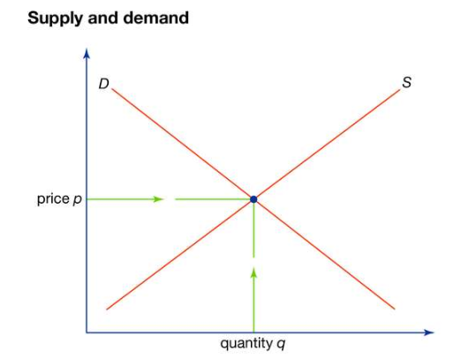
Alt text has been added to the above image. Note both the graph and title are part of the same screenshot image, and as such, alt text to give the title and to describe the graph must be added. The image will be read by a screen-reader as:
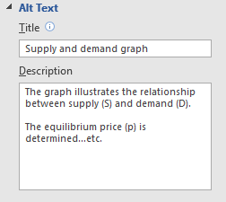
No alt text has been added to the image above, which is a screenshot of the alt text description attached to the graph. Someone using a screen-reader will therefore not be able to access the information the image portrays. It may read it as “image” or be skipped entirely.
Note also that the alt text for an image is not displayed visually on the document itself, so circumvents potential formatting issues.
Good practice in making course material accessible
With the above principles considered, teaching staff must prepare their course materials in a way which is accessible to students who use screen-readers. Some more nuanced points on the way materials must be designed and delivered are outlined below:
- Ensure consistent labelling, headings and numbering on any slides and teaching materials. This will help with ease of navigation, allowing screen-reader users to skim documents and revisit information more easily.
- Lecture slides converted to .pdf from LaTex/Beamer do not always work well with a screen-reader. The slides should be provided, in advance of the session, to the student in Word (.doc) or PowerPoint (.ppt) format. Staff should check with the student as to their preferred format.
- Microsoft Office applications such as Word and PowerPoint have in-built accessibility checkers. Enabling this will highlight any issues around content and formatting, missing alt text for example, allowing the author to easily amend the document.
- The most commonly used screen-reader, JAWS, can struggle reading algebraic and other complex mathematical notation. Some students may be experienced in using other software to decipher this material, others may prefer using braille. If the latter is the case, materials will be sent to an external agency for embossing. Naturally, this process takes time and needs prior preparation.
- Graphs that are integral to the understanding of a concept can be embossed to aid the learning process. As with braille embossing, this process takes time and prior preparation. Some graphs too may not translate well to tactile alternatives. Where graphs and other visual materials are used more as an illustration tool, and to add texture to the teaching session, a simple written explanation should suffice. Teaching fellows are therefore expected to use their own expertise and judgement to determine what is required to convey an understanding of the material they present.
Angus Lamb (Disability Adviser)
LSE Disability and Mental Health Service
a.r.lamb@lse.ac.uk / disability-wellbeing@lse.ac.uk

