FWOW
Future Ways of Working

Quick Guide: Mac Printer setup (Version 1.0 / 2 March 2022)

The information below will explain the process for setting up B/W and colour printing on LSE printers.

LSE owned MacBook:

Step 1: Installing the Printer Configuration
For LSE devices, users can install the printer configuration via the LSE self-service app. After opening the app, either select the category ‘Print and Scan’ or search for ‘LSE Staff Network Printer (Papercut).’

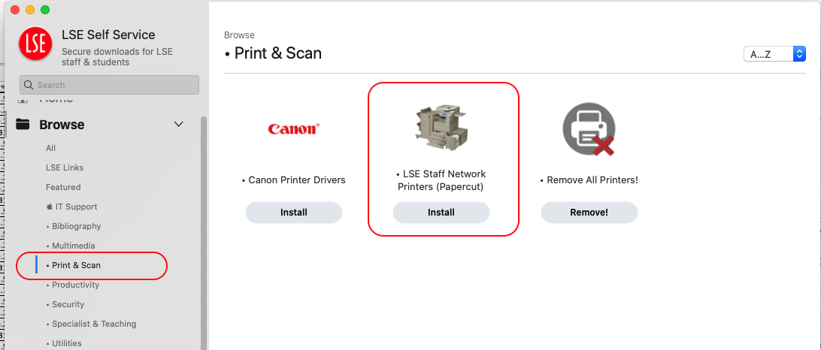

Step 2: Checking Printer Configuration
Once installed, please check your printer and scanner settings via ‘System Preference’ to ensure that, aside from the printer options listed below, you have no other LSE printer configuration setup.

- BW Staff Printer
- BW Staff Printer (Secondary)
- Colour Staff Printer – New
- Colour Staff Printer – New (Secondary)

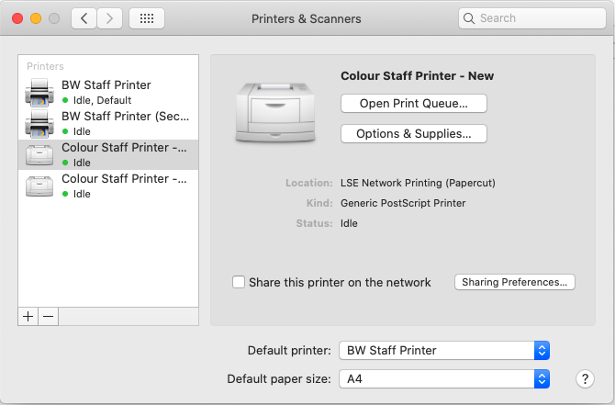

Following the above steps, you should be able to use the card reader on printers across the school.

Note: If after tapping your ID on the printer and no print queue is shown, please contact tech.support@lse.ac.uk with the serial number of the printer, located on the top of the device, as not all printers have been configured for Mac users.

Personal MacBook:

If you are using a personal device and wish to print on one of the LSE network printers, the setup process for this can be found here: Connecting to LSE printers from your Mac OS X laptop.

