Gloria Anzaldua’ s How to tame a wild tongue + Claude literacy

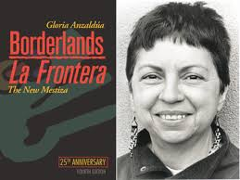
Content aims
- Reading and analysis of "How to tame a wild tongue" from Borderlands, La Frontera by Gloria Anzaldúa
- Evaluate some ideas from Anzaldúa in "How to tame a wild tongue"
- Apply Gloria Anzaldúa's ideas to the Spanish produced by Claude
Academic GenAI literacy
- Familiarize yourself with Claude
- Reflect on different aspects of LLM: sensitivity to word choice, authoritative voice and hallucinations, bias, sycophancy, working with your own documents.
- Develop Delegation (D1), Description (D2), and Discernment (D3)
Tools
- Chat in Claude

How to start a Claude Project

- Visit https://info.lse.ac.uk/current-students/digital-skills-lab/Claude and follow instructions

- Enter in https://claude.ai/ with your LSE account.

- Open a new chat

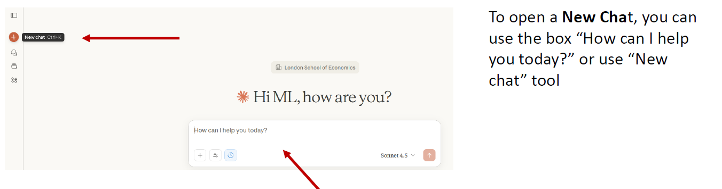

- In the new chat, you can activate the following elements:

- Web Search helps Claude access to current information
- Research allows for more thorough investigation of complex topics
- Extended thinking helps you see how Claude is reasoning
Note: some students have reported that Claude runs more slowly if you have the three elements activated.

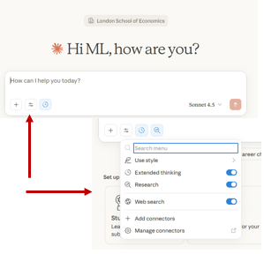

Activity 1. Who is Gloria Anzaldúa?
With machine. Start the conversation.
IMPORTANT NOTE: DO NOT copy the text in green into Claude - it's for you. Not for the machine.
Prompt 1. The context | Claude’ answers
COPY THIS TEXT IN CLAUDE'S CHAT

I am a Spanish student in a course titled LN220 – Spanish Language and Society. In the course we have a critical reading and text analysis workshop, where we learn to analyse and discuss texts while improving our Spanish.
My assignment this week is to read and analyse the text "How to Tame a Wild Tongue", included in the book Borderlands/La Frontera, by Gloria Anzaldúa.
Act as my academic assistant specialized in Spanish, sociolinguistics, literature and gender studies.
Your objectives are:
- Generate clear, precise, university-level content with accurate historical, sociolinguistic, and literary information.
- Facilitate requested tasks: text comprehension, summaries, analysis, and answering questions.
- Follow all instructions provided, including specifications on length.
- Always cite academic sources (journal articles, scholarly books, edited chapters) with complete references and links.
- Provide critical analysis suggestions to help understand Gloria Anzaldúa's ideas and their historical-cultural context.

Prompt 2: Main data about GA | Claude’ s answers
COPY THIS TEXT IN CLAUDE'S CHAT

The first task I have is the following. I need to write three brief presentations of Gloria Anzaldúa. One presentation is for an academic sociolinguistics journal, another for a literary magazine and another for a feminist blog.
These are the questions you have to use: · Who is the author? · Where and when was her book Borderlands/La Frontera published? · Is she known in her community? · What are the central themes of her work? · Why is Borderlands important/relevant for this audience? · What makes her unique or innovative?
The sources used must be relevant for each discipline.
Each presentation must be 70 words.

Without machine. After Claude's responses, reflect and take notes:
- What type of sources does it use? Are they academic as you requested? Have you verified it? How?
- Are the adaptations for different audiences convincing? Why?
- What have you learned about Gloria Anzaldúa's work by reading these three presentations?

Activity 2. “How to tame a wild tongue”
Without machine. Reading pages 33-40 "How to tame a wild tongue" by Gloria Anzaldúa at https://www.everettsd.org/cms/lib07/WA01920133/Centricity/Domain/965/Anzaldua-Wild-Tongue.pdf
- What type of text is it?
- What is the tone of the text?
- Make a list of ideas from the parts titled "Overcoming the tradition of silence" (p.34-37) and "Linguistic terrorism" (p.38-40)
With machine. Upload "How to tame a wild tongue" by Gloria Anzaldúa at https://www.everettsd.org/cms/lib07/WA01920133/Centricity/Domain/965/Anzaldua-Wild-Tongue.pdf to Claude.

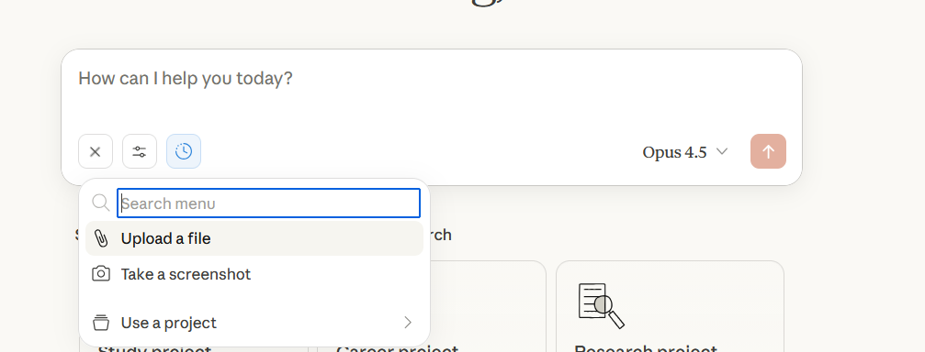

Prompts: several prompts to explore different aspects. The context comes from previous prompts. Pay attention: does Claude follow the instructions, give you the sources, etc. | Claude’ s answers
- COPY THIS TEXT IN CLAUDE'S CHAT. Now I need the following: can you make a list of ideas from the parts titled "Overcoming the tradition of silence" and "Linguistic terrorism"? (About 70 words each)
- COPY THIS TEXT IN CLAUDE'S CHAT.

Thank you. Very interesting. What variety of Spanish do you use? (about 50 words)
- NOW YOU HAVE TO QUESTION ITS RESPONSE. For example, if it told you that it uses a neutral variety, tell it "Impossible. There is no neutral variety" or "That's not true, your variety is very similar to northern Peninsular Spanish" or similar. Your comment has to question/deny Claude's response 3. Write your comment here:

Without machine. After Claude's responses, reflect and take notes:
- Compare Claude's list of ideas with yours. Do the ideas elaborated by Claude contribute anything more to your understanding of "Overcoming the tradition of silence" and "Linguistic terrorism"?
- Reflect on Claude's answers to questions 4 and 5. Do you agree with its answers?
Activity 3. Claude’ s opinion about GA’ ideas
With machine. Continue the conversation
Prompts: several prompts to explore different ideas. The context is given by the previous conversations | Claude’ s answer
- COPY THIS TEXT IN CLAUDE'S CHAT. This conversation is making me think about Gloria Anzaldúa's position and her writing style. Some people might think it's a brave stance – she defends her linguistic repertoire, claims her personal history and embraces it. At the same time, there's an element of "comfort". With her stance she doesn't have to master any language (70 words).

- COPY THIS TEXT IN CLAUDE'S CHAT. The ideas that Gloria Anzaldúa defends are really code-switching (code alternation) or translanguaging (translanguaging). I don't understand the difference. Can you explain it to me? I want to see the sources you use. (In about 150 words)
Without machine. After Claude's responses, reflect and take notes:
- How did the LLM respond to your comment from question 6? What is its stance? Do you detect any type of bias?
- Do you understand the difference between code-switching and translanguaging?

Activity 4. Beyond the text
Spanish
- Based on your experience with Claude, what variety of Spanish has it used? Is it 'neutral' Spanish or do you recognize characteristics from a specific region?
- What do you know about the decisions in LLM training? Where does their data come from?
- What voices and linguistic communities can be made invisible in LLM training?
- What consequences does it have that millions of people use the Spanish produced by LLMs?
- In your opinion, what would Gloria Anzaldúa say about the Spanish used by Claude?

Cognitive processes:
- What cognitive skills did you use to make the summary without Claude's help? Are they necessary skills? Why?
- What impacts can the (ab)use of LLMs have on your cognitive processes?

Environmental impact:
- Each query consumes energy. Is this cost ethical for tasks you could do yourself?
- Is it necessary to balance academic benefits with environmental responsibility? How?

Designed by Lourdes Hernández-Martín (Language Coordinator -Arabic and Spanish projects/ l.hernandez-martin@lse.ac.uk) with the support from Steven Williams (AI and Education Specialist, Eden Centre & Digital Skills Lab)

