Application process and deadline
Departments were asked in the summer to work towards the agreed LSE Offer 2020/21 (table is included for reference) as far as is possible during these very challenging circumstances, continuing to pay attention to the elements already agreed through the Academic Code and to the other areas of good practice highlighted, but in particular to focus on community building.
Please state the LSE Offer activity or activities (see the table - you can select more than one) that you are seeking additional funds for, give a very brief (one sentence) explanation of how the money will be used, and the number of students impacted. This will be a one-off bid process. Each department can bid once. The PDE and Education team will equitably allocate the relatively small available funds based on the submitted applications.
The LSE Offer table is included for reference.
Please return your application form to the Eden Centre (eden@lse.ac.uk) by COP Monday 25 January.
Department Name:

- Which LSE Offer activity / activities are you seeking additional funding for (please list each one):

- Please give a very brief explanation of what the funding will be used for – i.e. a one sentence description of what the money will be spent on and why, e.g. ‘to help with community building’:

- How many students are expected to be impacted:

- Please give a cost estimate for each activity (please be aware funds are very limited and may not cover the full amount being sought):

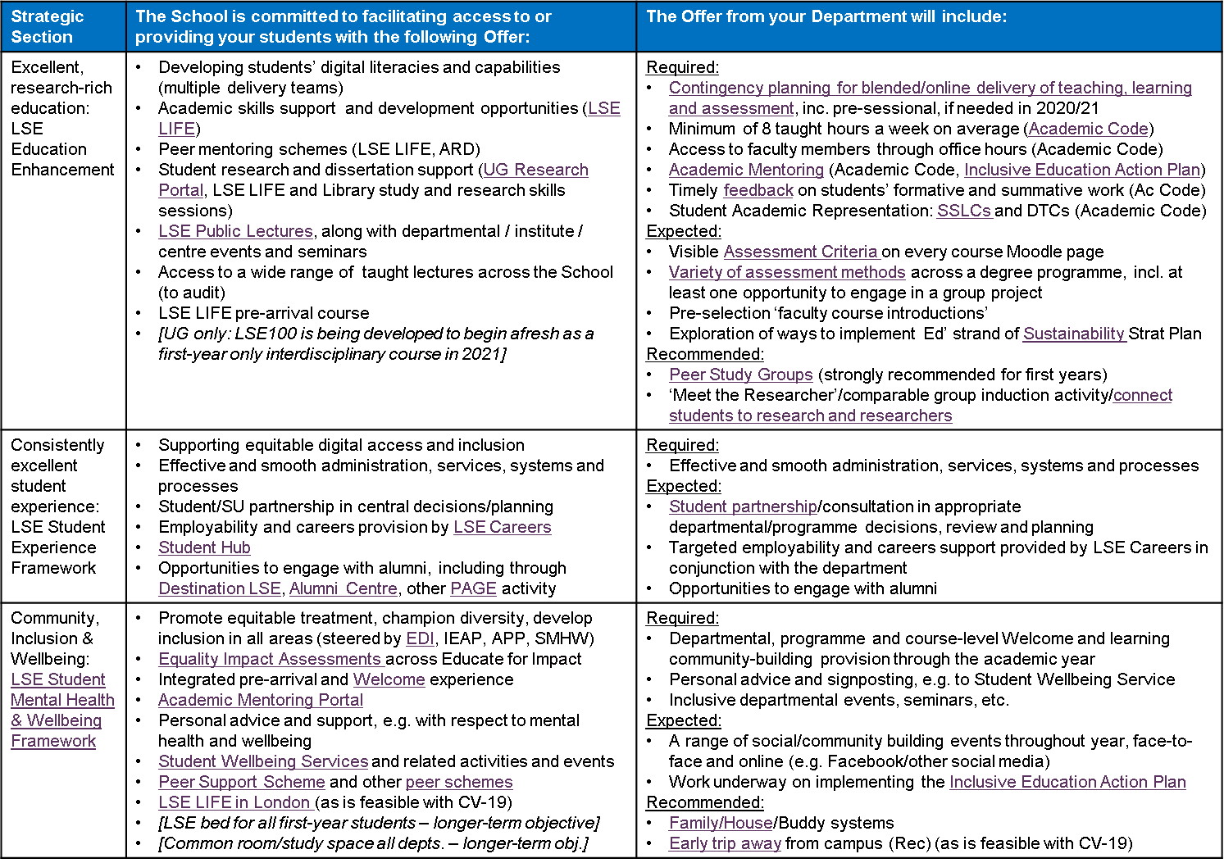
LSE Offer 2020/21

