Revision History – this document was amended on:

Revised by | Summary of Changes | Revision Date | New Version
Ioannis Tsolkas | Draft to be discussed | 08/07/15 | 1
Mike Ferguson | Reviewed by Finance Director | 10/09/15 | 1.1
Working Group | See Working Group minutes (29.10.15) | 29/10/15 | 1.2
Working Group | See Working Group minutes (25.02.16) | 25.02.16 | 1.3
Working Group | See Working Group minutes (17.05.16) | 17/05/16 | 1.4
Ioannis Tsolkas/Gary Barclay | Section 5. Special Leave, Staff Absence, Split Cost and Secondment. | 07/12/16 | 1.5
Ioannis Tsolkas | Definition of Terms | 06/03/17 | 1.6
SMC | See SMC minutes | 26/05/17 | 1.7
APRC | See APRC minutes | 06/06/17 | 1.8
Ioannis Tsolkas | Virement, DMs access to Professorial salaries, Starting Salary Policy, Staff Appointment Fund Check Procedure, Recurrent Vs Fixed term staffing changes. | 14/02/18 | 1.9
Gary Barclay | Transfers between Departments | 22/05/2018 | 2.0
Signed By: Name | Signed By: Signature | Signing Date | Version
Mike Ferguson |  | 18/02/18

Cash Staffing Budgets: Standard operating procedures –Academic Departments

The purpose of this document is to provide a set of rules surrounding the Cash Staffing Budgets (CSB) for Academic Departments.

Definition of Terms:

- Head of Department (HoD): An employee designated by the School as the Budget Controller for the CSB. The Budget Controller responsibilities are set out in the School’s Financial Regulations.
- CSB: A budget controlled by a HoD’s which presents and documents all approved centrally funded staffing costs.
- Establishment: A list of posts in a budgetary area, either filled or vacant, which are formally agreed by APRC. Changes to the list that require the net addition of resources will require approval through the Annual Monitoring (AM) process. Establishment Forms (CSB1) are managed and maintained by the Planning Unit.
- New Posts: Posts which are added to the Establishment through the AM process after they have been approved by APRC.
- Financial Planning & Analysis Manager (Pay Costs): The Finance Division employee responsible for producing salary forecast information for each Department and providing CSB support and advice to the HoDs and Departmental Managers (DMs).
- Pay Award: The annual percentage pay increase which increases all spine point salaries by the designated percentage amount.
- Contribution Pay and promotions budget: The budget approved by Finance Committee to fund recurrent and non-recurrent awards and promotions. Promotions and Awards proposals are reviewed by the Remuneration Committee and its sub-committees.
- Market rate supplements: A time limited addition to salary, reflecting the current market value of a specialist skill or subject area wherever possible. It must be approved by the Pro-Director (Faculty Development) and the Finance Director before the recruitment process begins.
- School Savings: A reduction in assumed levels of pay award (which is a change in budgetary assumptions, not a change in actual costs) is a School “central” saving. In the same way, an increase in costs owing to a change in budgetary assumptions would be a “central” cost. To avoid creating any budgetary incentives to discourage pension scheme membership any savings generated or costs incurred when a member of staff decides not to join or leave SAUL/USS will be classified as School savings or costs and the Departmental Vacancy Savings will be adjusted accordingly. Budgets and forecasts will assume that all vacancies will be filled by appointees who opt to join the appropriate scheme at the point of appointment.
- Departmental Vacancy Savings: The difference between the budgeted amount for a post and the actual costs generated for that post during a financial year (savings created from posts being vacant, starters appointed lower than 2 spine points above the bottom of the scale, etc.) net of any School Savings.

- General

a) Each relevant unit is allocated a pay budget by the School’s Council to fund the approved CSB1 (Establishment) of staffing. HoDs will receive confirmation of its composition prior to the start of each financial year, (1st August) for the forthcoming 12 months. The Department’s budget will be devised by calculating the salary cost of each employee (including NIC, Employer’s Pension contributions and Apprenticeships Levy), based on each member of staff’s salary spine point (incremental increases are taken into account by the model). This information is included in the salary forecast forms (CSB2s). This budget will be used to fund the establishment which is agreed between the HoD and the School, in agreement with APRC. Each year the budget for each post will be automatically increased by the agreed pay award.
b) The information will be kept on Excel spreadsheets (CSB1 and CSB2) in separate folders on the P drive and will be accessible by the HoDs and DMs and the relevant staff in the Finance Division and Planning Unit:
- Planning will have write access to the Establishment forms (CSB1) and will be responsible for maintaining and updating them. CSB1 forms will be updated on a quarterly basis in consultation with the Finance Division. Finance Division will have read access only. HoDs and DMs will have read access to the appropriate Department. (Annex 1a shows an example of the spreadsheet to be distributed).
- Finance Division will have write access to the CSB2 spreadsheets. HoDs and DMs, that have been authorized to access Professorial salaries, will have read access to the appropriate Department only. DMs that have not been authorised to access Professorial salaries will have read access to amended CSB2s that will exclude all information about Professorial salaries.
Security access for the Establishment forms will be granted by Planning Unit. Finance Division will provide security access to the CSB2 spreadsheets.
c) The HoD has overall responsibility for the CSB and cannot delegate it. The HoD remains accountable for all the spend on their budget, as well as the security and confidentiality of the data sent to them. This is a major change in the responsibility of the HoD, who previously was only responsible for the overall MSL balance in the 6 year planning cycle (Financial Regulation C2.4). All CSB2 reports will be saved into the P drive and access will be granted to the Budget Controller and the DM by IMT. In order to add an additional layer of security the reports are password protected and encrypted.
d) DMs will be given access to Professorial salaries only if both the HoD and Pro Director (Planning and Resources) approve. Neither the HoD nor the DM will be authorised to delegate access any further. Each time the HoD changes the DM’s access will be subject to this ‘double approval”. DMs will have to sign a confidentiality agreement. If the DM is not authorised, the HoD will manage the budget with assistance from Finance.
e) The Finance Division will provide monthly analysis, within 8 working days of the financial month closing. This will contain year to date actuals, a forecast of expected spend to the year end, year to date Departmental vacancy savings, actual and forecast “Additional Expenditure” (detailed in section 4) and post by post comparisons with the budget. (Annex 1b shows an example of the spreadsheet to be distributed).
f) Every second month meetings between HoDs/DMs and the Financial Planning & Analysis Manager (Pay Costs) will allow the salary forecast to be kept up to date and ensure that the unit remains within the budget for the year. More regular meetings can be arranged at the HoDs/DMs request.

2. Appointments

a) The CSB2 will have an entry for each full-time or fractional salaried member of staff who has a permanent or fixed-term appointment and is funded centrally by the School.
b) Where vacancies arise, and before a post can be advertised Departments should seek a 1st Funds Check (Establishment) from the Finance Division in order to confirm that the provided post grade, title, spine point, start date (where applicable) and FTE are consistent with the Establishment listing. All approved Professional Services 1st Funds Checks will be sent to the Chief Operating Officer (COO) automatically for information. The COO has the authority to halt the recruitment process even if a 1st Funds Check has been approved by Finance. After the successful candidate is identified and before a contract is sent Departments should seek a 2nd Funds Check as per section FIN_PRO XXX “Staff Appointment Fund Check Procedure” of the Financial Procedures. Details of the process are shown in Annex 2.
c) Automatic replacements for leavers will be included in the calculations as long as the grade is confirmed by the Planning Unit. It is the responsibility of the Department to inform the Finance Division if the post is not to be replaced. If the funds are required for a different position then the Department must follow the guidance in section 6.
d) Professional Services posts that are vacant when the Establishment is approved for the year will be allocated a budget 2 points above the bottom of the salary scale (reflecting current HR policy). Any savings achieved by the Department (placing the starter on the bottom 1.5 spine points in the band) can be used by the Department to meet other staffing needs. Any proposal to appoint at the contribution zone of a salary band or a market supplement will require written approval from HR before any oral or written offer is made to a candidate in line with HR’s “Starting salary policy”. Failure to observe this rule will be treated as a breach of the Financial Regulations as a financial commitment in excess of the budget will have been made. Academic posts will be subject to the New Academic Career structure.
e) Professional Services employees appointed above the bottom 2 spine points will need to be funded by the Department. Market rated supplements, if officially approved, will be added to the Unit’s budget, and funded from the central Recruitment and Retention budget.
f) Academic appointments made above the budgeted salary will be centrally funded as they are determined by the Pro-Director (Faculty Development). Similarly any savings arising from Academic appointments below the budgeted salaries will be excluded from the Departmental savings.
g) Under the CSB if sufficient funding is not available for an appointment then the request will be referred to the Finance Division and the Planning Unit who will follow the appropriate steps designated in section 6.
h) If there are significant changes to the job description and person specification it needs to be passed to HR for grading. If the grading is higher than the established grade the advice of HR should be sought.
i) All Assistant Professor appointments are subject to Interim (IR) and Major Review (MR). CSB assumes that IR will take place four years following the commencement of the appointment and MR will take place a further four years after that.
j) Departments under APRC Review are not permitted to make any permanent appointments or fixed term appointments of longer than one year (academic or PSS) or restructure during the review process (beginning from 1 August of the academic year of the Review, finishing when APRC formally releases the Department from Review) without first consulting the Chair of their Review Panel and the VC-APRC, and may face other restrictions on resource bids. The schedule of Reviews is below; a Department may also be held under Review from a previous year (not listed here). Special arrangements may also be put in place for a Department outside of this process – those Departments will be notified of the conditions directly. The schedule for future APRC Reviews is:

Please note that the schedule is indicative.
k) At the time of replacing an academic post the Department will agree with the Pro-Director (Faculty) and Pro-Director (Planning and Resources) the level at which the appointment should be made. The assumption in the forecast for planning purposes will be that all posts will revert to Assistant Professor level except endowed posts. Departments will need to discuss vacancies for named Chairs with the Pro-Director (Faculty) and Pro-Director (Planning and Resources); and are encouraged to do so well in advance. Agreement to appoint a Chair will mean funds continue at the Chair level (rather than Departments having to reallocate resources).
3. New Posts

a) All applications for extra staffing require the unit to define a specific post title and make the case during the AM process. If agreed, this post will be included on the Unit’s Establishment form (CSB1). For clarity and consistency the unit should use the same post title agreed through the AM process when completing recruitment documents.
b) Funds for New Posts will not be released until a post is first appointed. Departmental vacancy savings will exclude any savings generated from New Posts.
c) Funds may be released for New Posts when short term staffing arrangements are in place to cover work while recruitment is in progress. Any such request should be made to the Financial Planning & Analysis Manager (Pay Costs) to approve the release of these funds.
d) If a New Post remains unfilled for more than 6 months from the agreed start date, the unit will be contacted and asked for comment about the resourcing needs. A report will be regularly produced and sent to the COO by the Finance Division detailing all New Posts which have been approved but not filled.
e) New posts are subject to FIN_PRO XXX “Staff Appointment Fund Check Procedure” of the Financial Procedures so a 1st and 2nd funds check should be generated by the department at all times. Details of the process are shown in Annex 3.

4. Additional Expenditure: Hourly Paid Staff / Temp Costs / Overtime.

a) Each Unit will be allocated a budget for “Additional Expenditure” (to meet costs detailed in Annex 4), which requires agreement through the AM process. The size of this budget will be determined by the individual factors affecting a Department, i.e. the seasonality and nature of the work performed. All Units are required to make a case annually for “Additional Expenditure” required as part of the AM process. It will be assumed that if no case is made there will be no changes to the “Additional Expenditure” budget for future years.
b) The “Additional Expenditure” budget will be combined with the CSB calculated from the Establishment to form the overall pay budget for the year for the Department. As budget controller the HoD will be responsible for the “Additional Expenditure” budget, ensuring that the total Cash Based Salary Budget is not overspent.
c) If an Establishment post is not filled in a year or a proportion of the year (creating vacancy savings) the savings can fund “Additional Expenditure” to cover the work normally completed by the vacant post. The simple example below shows how this process would work. Prof. D’s position is vacant for the year and the funds are spent on GTA’s, Guest Teachers and Overtime:

Post | Name | Budget | Actual
a | Dr. A | 10 | 10
b | Dr. B | 10 | 10
c | Dr. C | 10 | 10
d | Prof. D | 10 | 0
e | Dr. E | 10 | 10
f | Prof. F | 10 | 10
g | Sir. G | 10 | 10
 |  | 70 | 60
Additional Expenditure: | GTA’S | 5 | 10
 | Guest Teachers | 5 | 5
 | Overtime | 0 | 5
 |  | 10 | 20
Total |  | 80 | 80

- Departmental vacancy savings will be clearly identified in the monthly salary forecast. Upon request the Financial Planning & Analysis Manager (Pay Costs) will provide a breakdown of the total vacancy savings available per month (e.g. post title, previous employee name, etc.).
e) To ensure that “Additional Expenditure” is updated in a timely manner it is important that Temp invoices are passed to Accounts Payable in the week that they are received to ensure that they are efficiently reflected on the CSB spreadsheet.
f) All agency temp staff must be booked via the Schools preferred suppliers (follow the link for a list of the School’s current preferred suppliers). If you are planning to use an alternative supplier you will have to contact Procurement before you book any agency temp staff.

5. Special Leave, Staff Absence, Split Cost and Secondment.

a) Any unpaid leave granted to an employee will allow the Unit to spend the leave period savings on staffing to cover the leave. This can be in the form of a secondment replacement, acting up allowances, a fixed term contract, payments of “Additional Expenditure” or a combination.
b) The actual cost of a member of staff on maternity or sick leave will be included in the Unit’s forecast spend for the year. The Department can request assistance with additional costs required to recruit temporary replacement staff from the APRC Sickness and Maternity Contingency fund. Funds are only normally available where other funding within the Department is exhausted.
c) If members of staff are absent on secondment the Department saves their costs and is free to spend the savings to cover the work.
d) When a member of staff is absent through long-term sickness or on maternity leave, the forecast will be amended to reflect any reduction in cost.
e) Where Statutory Maternity Pay (“SMP”) is payable, 92% of the net SMP paid can be recovered by the School from HM Revenue and Customs. This will appear as a reduction in cost for the employee involved on the face of the Cash Based Pay Forecast (form CSB2).
f) Split Cost (Temporary): If the salary is being moved into a non-CSB it will result into a saving for the CSB. If the salary moves from CSB into another CSB is up to the Departments involved to negotiate the change.
g) Split Cost (Permanent): A permanent move from a CSB into a non-CSB will have to be approved by Planning. If the salary is being moved from CSB into another CSB then the budget should move. Permanent split costs requests should be requested in the AM process.
h) Secondment (not related to a Grant): It can only be temporary. If the salary is being moved into a non-CSB it will result into a saving for the CSB. If the salary moves into a different department within CSB it is up to the Departments involved to negotiate the change.
i) External Secondment (related to a Research Grant –Used to be referred to as Buy-Out). The salary will continue to be charged on CSB. Research Division will credit the substitute teaching account and debit the relevant research project (internal or external).

6. Promotions and changes to the approved Establishment

As detailed in section 1, the Establishment represents a budget approved by Council. Any change to staffing (promotions, additional or discretionary increments, changes in working hours, etc.) that creates additional cost requires an appropriate budget to pay for it. As a consequence of this constraint care should be exercised by HoDs/DMs when considering re-organisations or revisions to job descriptions to ensure that the budget to fund any resultant additional costs has been identified and approved. The Financial Planning & Analysis Manager (Pay Costs) will aid the Department in producing the financial analysis and associated business case necessary to support this. Changes to the Professional Services Establishment will have to be approved by the Director of the Finance Division (in liaison with the COO) and changes to the Academic Establishment by the Pro-Director Planning and Resources.
A change that does not have an effect on this year’s budget could have a detrimental effect over the planning cycle (current year + next 5 years) and therefore is not permitted. Recurrent staffing changes (such as permanent changes in fte, salary band or conversion of fixed term posts to permanent) can only be funded by recurrent savings. Fixed term changes can be funded by the forecasted underspent/carry-forward. HoDs/DMs must seek advice from the Finance Division before any decision is made. Departments that fail to do so might have funds clawed back from their Additional Expenditure budget over the planning cycle (current year + next 5 years).

a) HERA Promotions

i) Given that all Professional Services posts have now been assessed through the HERA job evaluation process, in broad principle a re-grading should only occur through restructuring of work or where new duties are being undertaken by an individual. In those cases, where extra resources are required to support a re-grading, this will need to be agreed through the AM process and supported by resources allocated by APRC for that purpose or from the Discretionary awards and promotions budget.
ii) Before a post (or posts) is modified and re-graded by HERA the HoD must, with the assistance of the Financial Planning & Analysis Manager (Pay Costs), identify and secure approval of the budget or budget allocation to meet any cost implications.

b) Restructuring/Re-organisation

i) Any proposed changes to the composition of the Establishment (which are not individual promotions) resulting in an increase in cost should be detailed and requested in the AM process.
ii) If unfilled New Posts are not affected by the suggested re-organisation the Finance Director can approve the proposed changes.
iii) Departments under APRC Review are not permitted to make any permanent appointments (academic or PSS) or restructure during the Review process (beginning from 1 August of the academic year of the Review, finishing when APRC formally releases the Department from Review) without first consulting the Chair of their Review panel and the VC-APRC, and may face other restrictions on resource bids.

c) Contribution Pay

Contribution pay (whether lump sums, accelerated increments within the standard range of a salary band or additional increments within the contribution range) are currently awarded through a collective process and funded from a separate budget. Where awards are made they will be accompanied by a transfer of budget from the Contribution Pay budget to the Department’s CSB2 form.

7. Premature retirement, voluntary severance packages and arrangements relating to annual leave for leavers

a) In accordance with the Financial Regulations proposed severance packages require approval of the Directors of HR and Finance Divisions. Budgetary implications of severance proposals must be properly understood. The Financial Planning & Analysis Manager (Pay Costs) will assist in the preparation of such a business case as required. The one-off costs of premature retirement or voluntary severance packages will ordinarily be charged to the organisational unit's CSB (form CSB2). If insufficient funds are available to cover the cost and allow the normal operation of the Unit it will be met by the central budget.
b) Leavers are entitled to annual leave on a pro-rata basis in the year in which they leave which will be reflected as follows:
i) If a leaver has untaken holiday paid as a lump sum this cost will be reflected on the CSB (form CSB2).
ii) If a leaver has taken more holiday than entitled they will be charged the element of leave that exceeds their pro-rata entitlement. This will result in less spend showing on the CSB (form CSB2).

8. Carry forwards

a) At Year end Departments will be allowed to carry forward any unspent balances to the next financial year. Carry forwards will be capped at 20% of next year’s budget. For example if the 2016/17 underspend is £400k and 2017/18 budget is £8m the Department will be allowed to carry forward 100% of the underspend. If the 2016/17 underspend is £450k and the 2017/18 budget is £2m only £400k will be allowed to carried forward (20% of £2m = £400k).

9. Virements

Virement within Budget Groups held by a Budget Controller are allowed subject to approval by the Budget Controller’s Line manager. Virement between Budget Groups
may be possible however if it leads to an increase in staff Establishment headcount, FTE or (in some cases) grade it requires an additional level approval by the Finance Director and, in the case of academic departments, the Pro-director Planning and Resources in accordance with the Financial Procedure for virements (link).
Given the additional complexity of the process, it is recommended that proposals which fall into this category are discussed with the relevant FP&A manager before preparing form B/2.

Virements are permanent transfers. To avoid undermining the authority of Budget Controllers to manage their budgets responsibly, a permanent record of Virement will be retained and a subsequent request for additional resources for budgets which had previously been subject to Virement will require additional justification and may be declined on that basis.

10. Transfers between departments

All transfers of academic staff between departments need to be approved by the Director. While the Director or Pro-Directors will often facilitate these transfers, it is important to note that a solution will not be imposed upon Units and that there are no additional resources to support such transfers. Successful transfers are contingent on an agreement being reached between the academic and the relevant Heads of Department. This may involve issues including academic fit with the new Department, the transfer of courses, or the development of new courses. Heads of Department will also need to consider the implications of a transfer on their Resource Allocation profile.

11. Pay Awards and Employer Taxes

a) Council approves the budget for the forthcoming financial year in June. At this time the pay award may not be finalised.
b) When the pay award is not settled at the start of the year an adjustment will be made to ensure that Departmental vacancy savings exclude School vacancy savings.

Annex 1a

Annex 1b

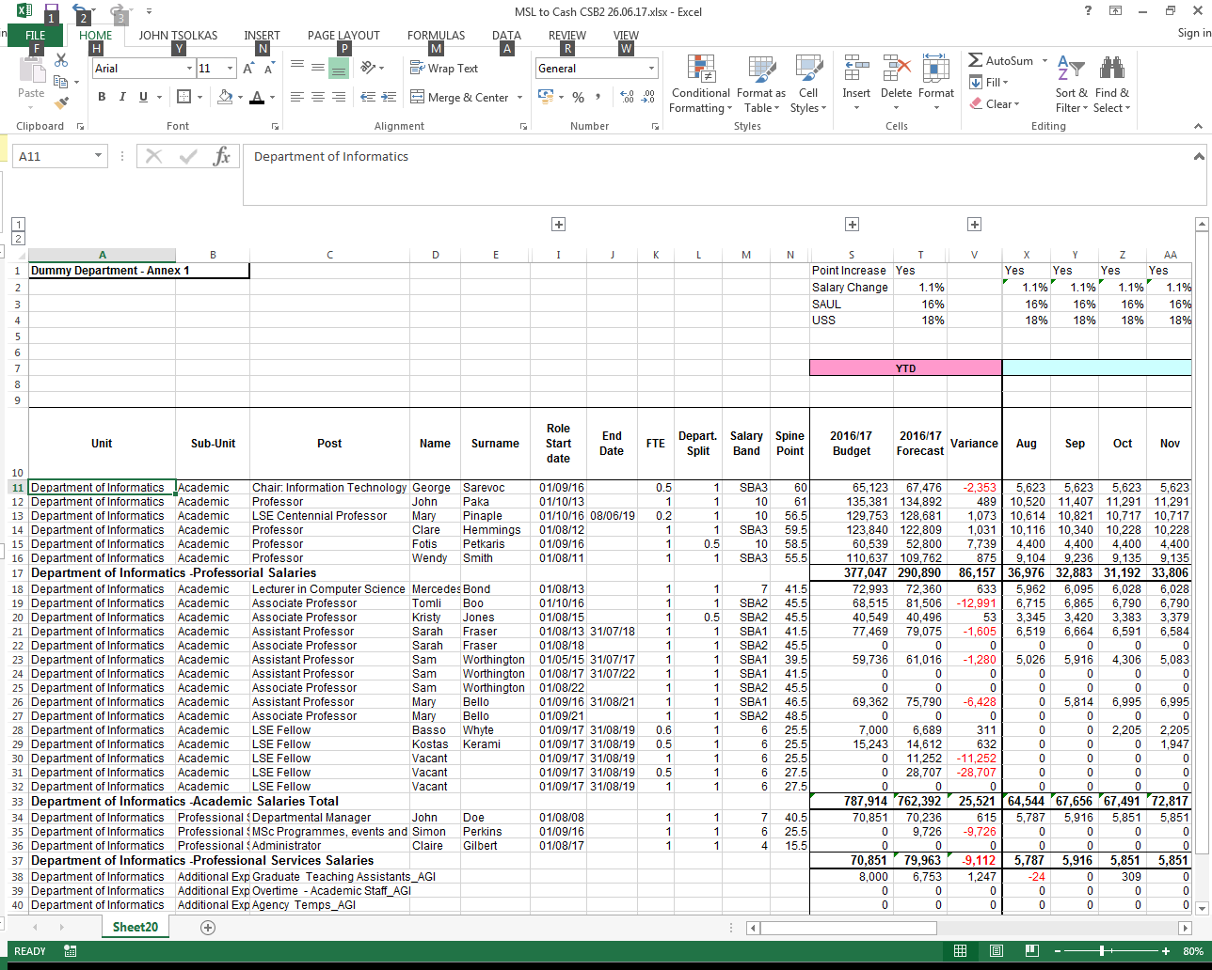
Annex 2 – Diagram of Recruitment Process (Existing Posts)

Academic Department
1st Fund Check – Establishment

Oral offer made – Contract sent

Post Advertised
Interviews
Approved

2nd Fund Check - Appointment
Appointment

Successful Candidate Identified

Approved

Annex 3 – Diagram of Recruitment Process (New Posts)

Academic Department

HR
RF2
HERA
1st Fund Check – Establishment

Oral offer made – Contract sent

Post Advertised
Interviews
Approved

2nd Fund Check - Appointment
Appointment

Successful Candidate Identified

Annex 4:

Additional Expenditure:

Expense Description | Expense Code
Overtime | 30051
Hourly Paid Support Staff | 30052
Agency Temps | 31055
Honoraria | 30180
Hourly Paid Research Assistant | 30190
GTA/Guest Teachers | 30033
Library Security Temps | 31065
Agency Placement Costs | 31055
Consultants | 30500
Recruitment Costs | Over and above whatever HR pays for
Training and Development Costs | Over and above whatever HR pays for

Annex 5:

Unspent Staff budget virement examples:

Expense Description | Expense Code
Advertising Costs | 52020
Staff Training and Development | 52081
IT Equipment | 46001
Phones | 40013
Other Office Equipment | 43001
Subscriptions | 51001

There is a budget for contribution pay (lump sums and increments); an allocation to cover promotions; and a Recruitment and Retention Allocation for exceptional R&R packages, including new awards of market supplements.

