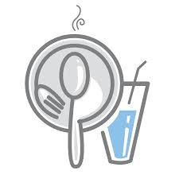

Kitchens, food and drink
There is one shared Kitchen area in LRB R5.02, shared between Finance Division, Human Resources and EDI.

Tea, milk, coffee, sugar, sponges and washing-up liquid are provided by LSE.

Use of the kitchen and its facilities is a privilege, and users are expected to maintain cleanliness and tidiness at all times. The state of the kitchen will be actively monitored – if standards are not maintained then a rota system of cleaning may be implemented!

Users are responsible for cleaning the microwave and fridge after use, washing up after themselves and cleaning up any spillages. Items should NEVER be left in the sink ‘to soak’ as this blocks the sink for other users.

If storing items in the fridge please ensure you mark-up wherever possible, and throw out unused or stale items. Fridges are occasionally emptied and any out of date or perishable items with no-one’s name on will be thrown away.

Colleagues are asked to supply their own cutlery, crockery and cups for use.

Strong-smelling foods should be eaten in the kitchen, rather than at your desk in the general office area, as the odours may offend fellow colleagues.

