Accessing desktop Microsoft 365 Copilot
- In the search bar next to the Start icon, enter Microsoft 365 Copilot and select the app.
- This will open Copilot Chat. We suggest you pin this to your taskbar for quick and easy access.
Note:
You can access Microsoft 365 Copilot in your browser for the most up-to-date experience. The web version receives new Copilot features first and does not require any software updates. Open it here: https://m365.cloud.microsoft/
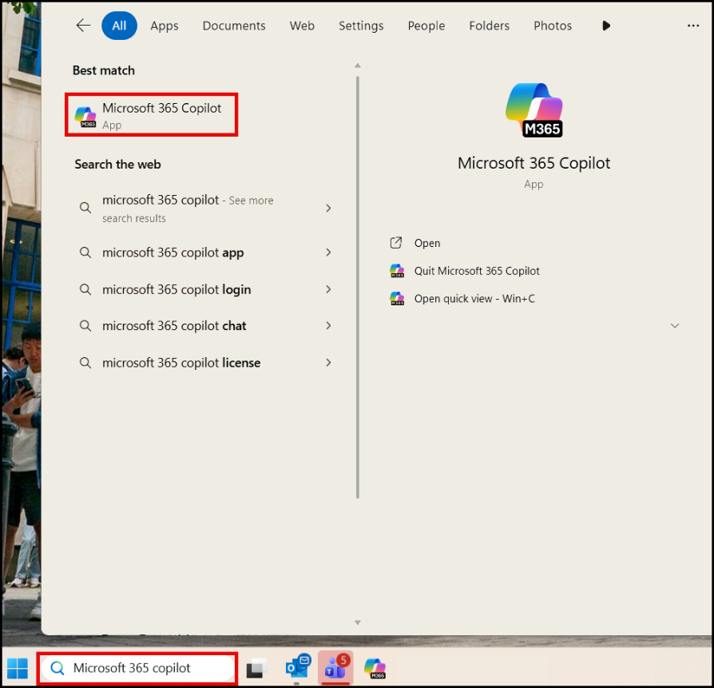

Accessing Copilot in Microsoft Apps
Copilot is available and integrated across Microsoft 365 apps, including Excel, Word, PowerPoint, Outlook, and Teams.
- Once you have opened Excel, PowerPoint, Outlook, or other Microsoft 365 apps, the Copilot icon sits in the ribbon, typically on the right-hand side. The example shown is using Excel.
- Click the Copilot icon to start using Copilot in the app.
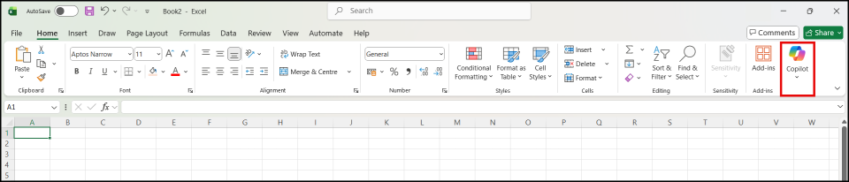

When to Use the Microsoft 365 Copilot vs Integrated Copilot in an M365 App
You can use Copilot in different ways depending on the task you want to complete. You can learn more about the differences and use-case examples in our App vs Integrated Copilot guide.
Use the Microsoft 365 Copilot when you want to create something new
Use the Chat app to draft or develop fresh content, such as:
- Introductions
- Checklists
- Summaries
- Ideas or first drafts

It is the easiest place to refine wording and then copy the result into your email, document or presentation.
Use integrated Copilot inside Word, PowerPoint or Outlook when working with an existing file
Use Copilot inside the app you are already in when you want to:
- Rewrite or improve existing text
- Summarise the current document
- Generate slides from a report
- Draft or edit an email you have open

