How to ground your prompts

Overview
This guide explains what happens when you type / in Microsoft 365 Copilot, why you might use it, and how it helps Copilot produce more accurate and useful results.
When you type /, Copilot opens a small menu that shows your recent files, emails, meetings and other content. This allows you to quickly choose something Copilot should use when responding to your request. This action is called grounding. Grounding means you give Copilot the exact information it needs instead of relying on general knowledge. This makes Copilot’s answers more precise, more relevant and better aligned with your work.

Why You Would Use “/”
Use / when you want Copilot to work directly from your own files and content, which helps it produce more accurate and useful results.

Use / whenever you want Copilot to:
- Summarise a document
- Rewrite or improve something you already have
- Create a new document based on existing content
- Compare two files
- Pull details from an email thread or meeting
- Avoid generic or inaccurate answers

Typing / prevents guesswork, as Copilot works directly from the file you select.

How to Use / Step-by-Step
- Open Copilot in Word, PowerPoint, Outlook, Teams, or Microsoft365.com. In this example, we have opened Microsoft 365.com.
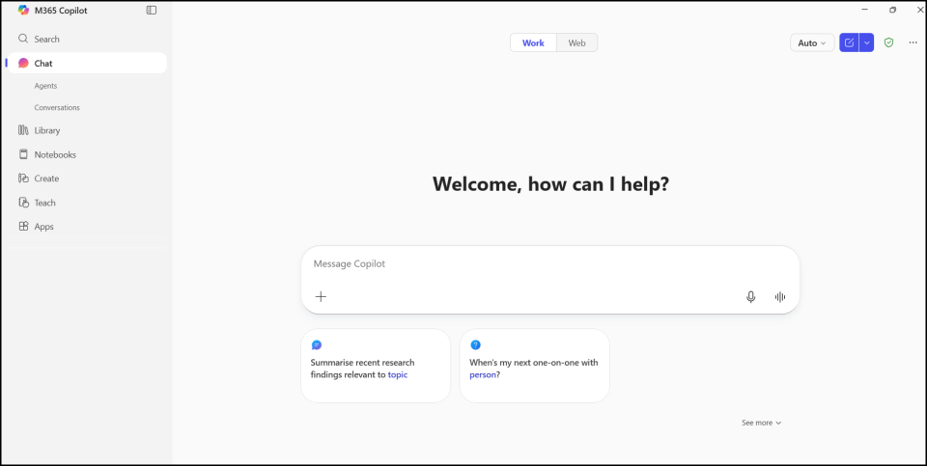

- Start typing your prompt. In this example we are asking Copilot to summarise the following document.
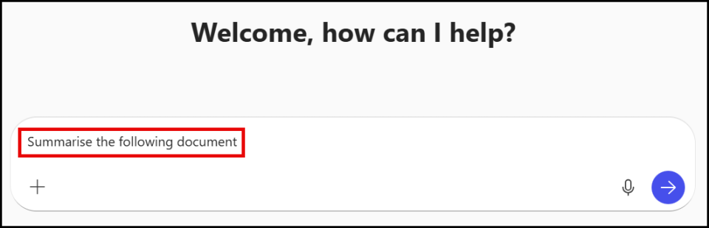

- Type / at the end of your prompt.
As soon as you type /, you will see a list of:
- Recent documents
- OneDrive/SharePoint files
- Emails
- Meetings
- People
- Other available content types (this is where you add your screenshots.)
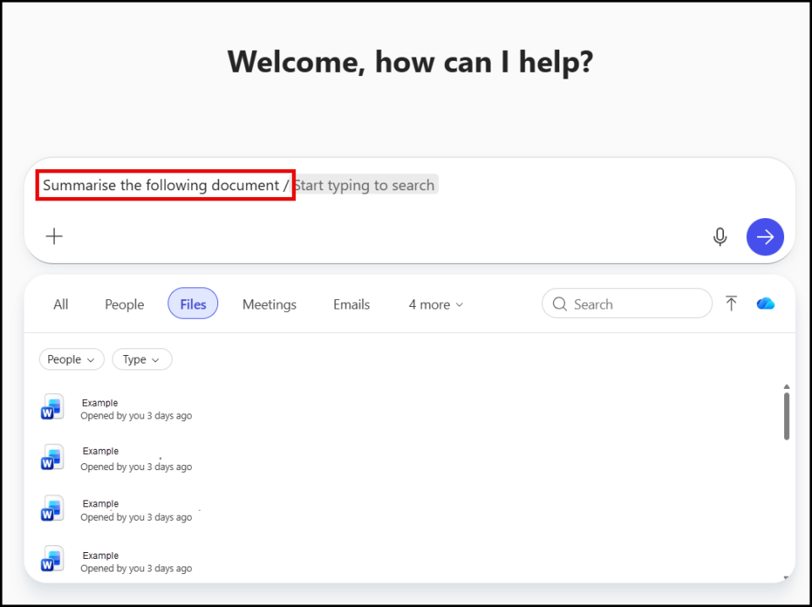

- Select the document or item you want Copilot to reference (you can select multiple items).
Note: click more to show more options.
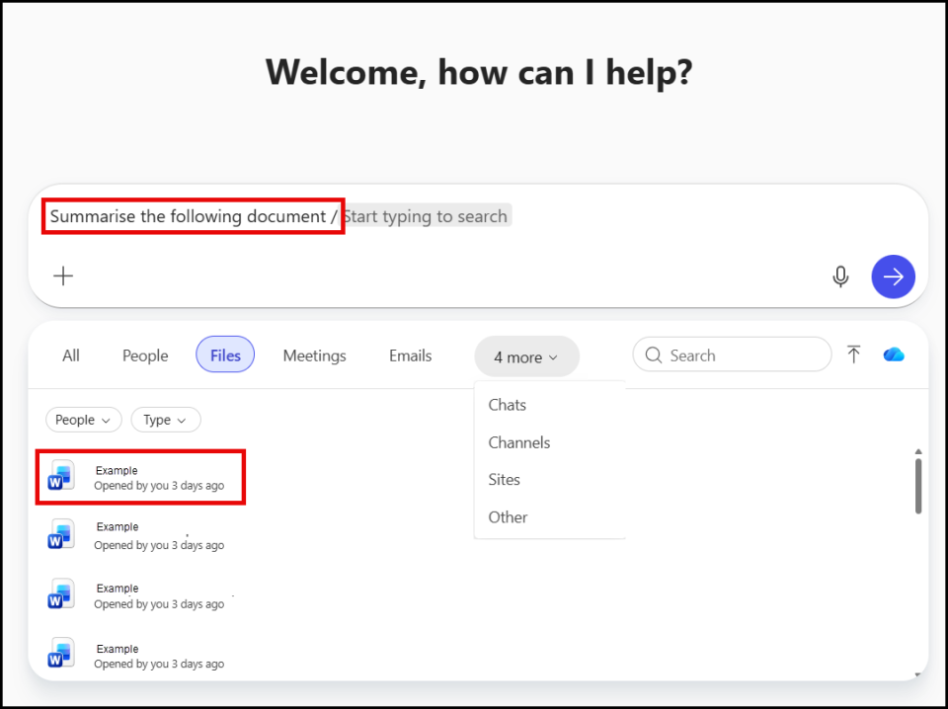

- The document will appear in the prompt, finish your prompt and send. Copilot will now generate an answer based on the specific content you attached, not general information.

