Managing Your Copilot Memories: How to Add, View, and Remove Preferences
Overview
This guide explains how to personalise your experience with Microsoft Copilot by using Memories. You’ll learn how to add details that help Copilot tailor its responses, view what’s already stored, and remove information you no longer want remembered. By managing your memories effectively, you can make Copilot smarter, faster, and more relevant to your daily work.

What are Copilot Memories?
Copilot Memories are personalised pieces of information you share with Microsoft Copilot to make your experience smarter and more relevant. Think of them as context markers: details about your role, preferences, projects, or key collaborators that help Copilot tailor its responses to your needs.
Instead of starting from scratch every time, Copilot uses these memories to save time by reducing repetitive explanations such as your job role or preferred formatting. It provides context-aware answers that align with your responsibilities and priorities. It improves accuracy by factoring in your team, tools, and workflows. It enhances productivity by anticipating what matters most to you, such as suggesting relevant documents or summarising updates for your projects.
For example, if Copilot knows you are managing a project, it can prioritise resources, templates, and best practices related to planning, tracking progress, and stakeholder communication. Similarly, if you often work with certain colleagues, Copilot can surface relevant communications or files involving them.

Adding Memories
You can add memories by telling Copilot what you’d like it to remember, such as your role, preferences, or key projects.
- Open Copilot Chat.
- Type a message telling Copilot what to remember, for example: Remember that I am managing a project called Digital Transformation.
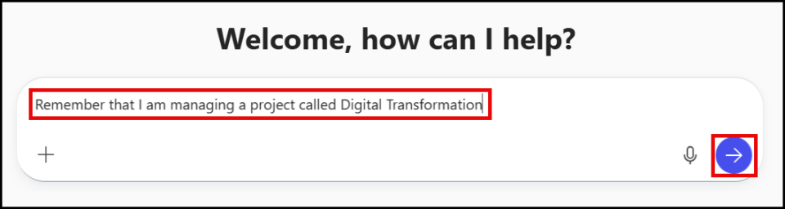
- Click on the Send icon.

- Copilot will confirm that the memory has been saved.
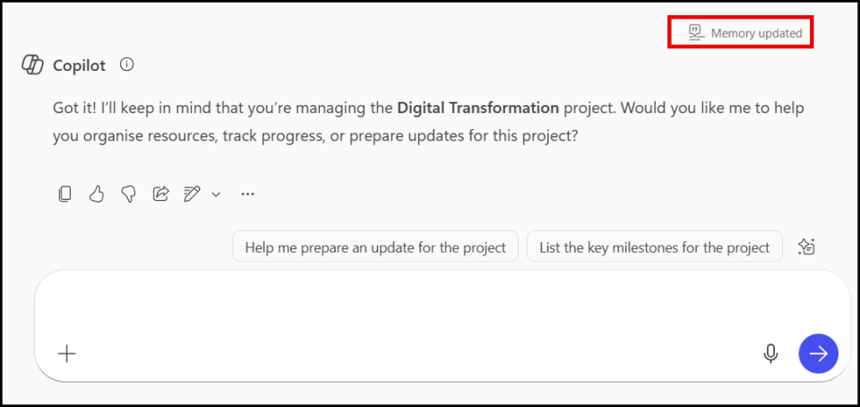
Note:
Copilot may ask additional questions, which you can review and decide to action.

Viewing your saved Memories
At any time, you can ask Copilot to show what it currently remembers about you to keep track of your stored preferences.
- Open Copilot Chat.
- Type What have you remembered about me?
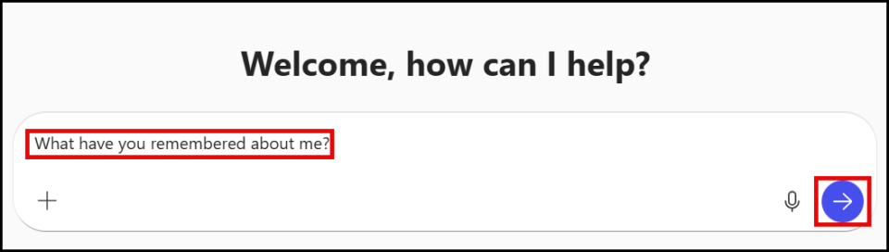
- Click on the Send icon.
- Copilot will display a list of all saved memories.
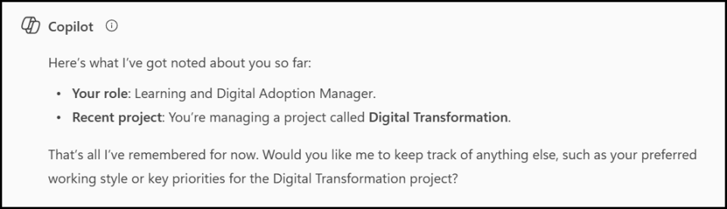

Removing or updating Memories
If something changes or you no longer want Copilot to remember certain details, you can remove or update memories with a simple command.
- Open Copilot Chat.
- Type a message to remove a memory, for example: Forget that I am managing Digital Transformation project.
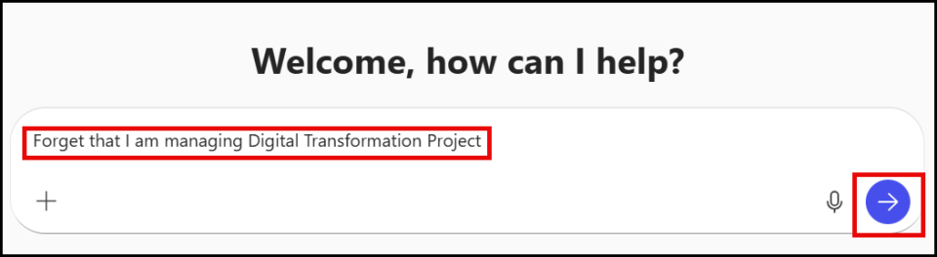
- Click on the Send icon.
- Copilot will confirm that the memory has been deleted.
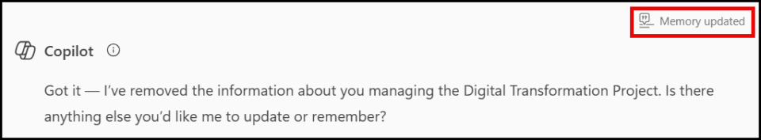

Note:
To remove all memories say: Delete all my saved memories.

Best practices for managing memories
Managing memories effectively ensures Copilot delivers accurate, relevant, and consistent support. This section provides practical tips on what to share, how to phrase it, and why keeping your memories updated is essential for maintaining productivity and alignment with organisational standards.
Why It’s Important to Keep Memories Updated
- Accuracy and relevance: Outdated memories can cause Copilot to provide incorrect context or prioritise the wrong projects.
- Better productivity: Current information ensures Copilot surfaces the most relevant files, summaries, and suggestions.
- Improved collaboration: Updated memories help Copilot highlight the right stakeholders and resources for your active work.
- Avoid confusion: Removing old or incorrect details prevents Copilot from making assumptions that no longer apply.
When Memories May Not Be Useful
- If the information is temporary or irrelevant: For example, short-term tasks or one-off events don’t need to be stored because they’ll quickly become outdated.
- If the memory is too vague: Copilot works best with specific details. A memory like “I work on projects” is less helpful than “I am managing the Digital Transformation project.”
- If the memory contains sensitive or personal data: Avoid storing confidential information that isn’t necessary for Copilot to assist with work tasks.
- If your role or priorities change frequently: In fast-moving environments, static memories can quickly become inaccurate and lead to irrelevant suggestions.
Getting started with Copilot Memories.
Here are some practical examples of useful memories to add. Each suggestion includes why it matters and a ready-to-use prompt you can copy edit, and paste. These examples are designed to improve efficiency, ensure responses match your organisation’s tone of voice, and keep Copilot aligned with your role and priorities.
Memory to Add | How This Helps | Suggested Prompt
Your job title and responsibilities | Copilot can tailor responses to your role, suggest relevant resources, and prioritise tasks. | “Remember that I am a Learning and Digital Adoption Manager.”
Current projects or initiatives | Ensures Copilot surfaces updates, files, and summaries related to your active work. | “Remember that I am managing the Digital Transformation project.”
Preferred response style | Copilot delivers answers in the format you like, e.g., concise summaries or detailed explanations. | “Remember that I prefer concise summaries with headings.”
Language and tone preferences | Maintains consistency with organisational standards, e.g., British English or formal tone. | “Remember to use British English in all responses.”  “Remember to use the LSE tone of voice: clear, professional, and approachable.”
Key collaborators and stakeholders | Helps Copilot highlight communications and documents involving your team. | “Remember that I work closely with Barbara Streisand and Bob Massingbird.”
Important deadlines or milestones | Copilot can remind you of timelines and prioritise related tasks. | “Remember that my project deadline is 30 March.”
Tools and platforms you use frequently | Suggests relevant guidance and integrates with your preferred apps (e.g., SharePoint, Teams). | “Remember that I use SharePoint for document storage.”
Recurring meetings or routines | Prepares summaries and agendas for regular sessions without you asking each time. | “Remember that I have a weekly project update meeting every Monday.”
Department or team name | Provides context for organisational updates and relevant documents. | “Remember that I am part of the Digital Skills Lab.”
Preferred file types or templates | Speeds up document creation by recommending the right templates or formats. | “Remember that I prefer PowerPoint templates for presentations.”

