
Giving collective feedback on exams

NOTES OF GUIDANCE 5

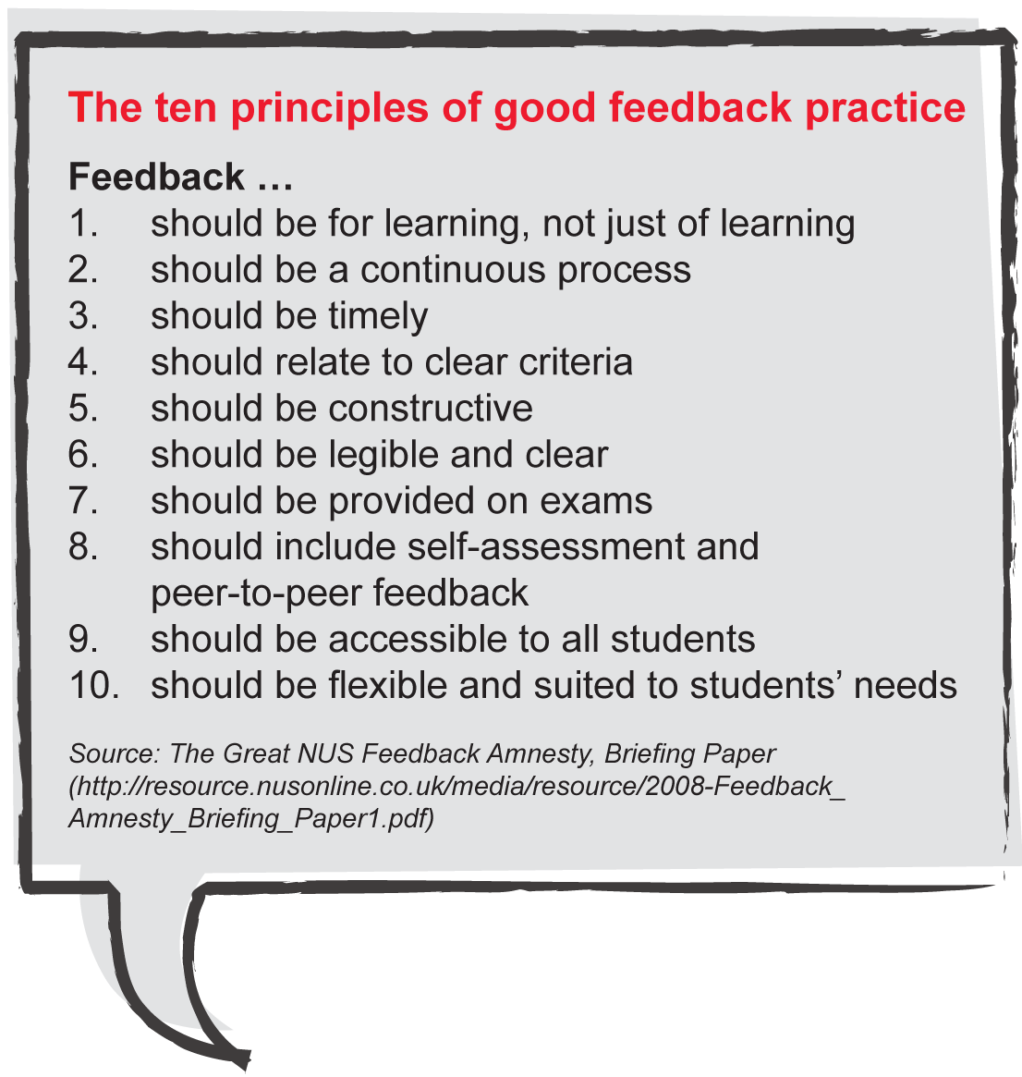
Welcome to the latest title in the Feedback series from LSE’s Teaching and Learning Centre. This note follows a specific recommendation accepted by the June 2010 Academic Board (AB30 03.06/2010) which indicated that ‘examiners should provide feedback on students’ examination performance in the form of collective feedback … [This] collective feedback will take the form of a summary of the examinable material students handled well, and of the material they found difficult.’ This note provides guidance on doing this, with the expectation that departments will pilot the process on one first year undergraduate exam only.

Why give feedback on exams?
Giving feedback on exams

NOTES OF GUIDAN
There is clear indication from students both nationally and from within LSE that feedback on examinations is important to them. This is evident from Principle 7 of the NUS Feedback Amnesty (opposite), and the increasing use of Freedom of Information requests by LSE students to see the comments on their examination papers. Offering feedback on an individual basis is problematic and School regulations are intended to protect staff from such requests. However, the use of collective feedback offers a compromise that appears to fit LSE’s heavy examination focus. It should:
- be of particular value to re-sit students;
- provide general feedback to the cohort who sat the exam;
- serve as a revision tool for the incoming cohort.

What is expected?
In the first instance, it is proposed that collective exam feedback is trialled on a selection of first year

undergraduate courses. Each department is asked to
choose one course for the trial in 2011. A useful course to select would be one that features higher than average failure rates or where students perform less well than might be hoped/expected relative to the department’s overall portfolio of first year undergraduate courses. This trial will be reviewed before any further steps are taken.
As with any feedback, it needs to be timely. It is proposed that collective examination feedback be provided electronically to students shortly after marking is completed (ie mid-July for undergraduates and 9-month Masters students, late October/early November for 12-month Masters students). Departments may then want to explore how to capitalize on this material with their students (see ‘Additional benefits’ at page 4 of this note).
What should collective feedback on exams comprise of?
To serve the purposes outlined above – offering guidance to re-sit candidates, general feedback to current students and providing guidance alongside past papers for future students – collective feedback on exams can usefully be divided into two sections – general and specific.

Section 1: General comments
The first section offers general feedback – for example which questions many students attempted, which were only considered by a few, which questions were generally answered effectively and which ones students struggled with. It can also give students a clearer understanding of how examiners use the marking criteria, and (as appropriate) how those criteria are or are not addressed effectively in students’ answers. So, for example, in qualitative ‘essay style’ papers, this general feedback might refer to how students are addressing questions, their use of evidence (scope/breadth/appropriateness), the quality of argument. For quantitative papers, it might focus on the balance of technical skill and intuition, the elegance of solutions to problems, or the appropriateness of approaches selected.

Section 2: Question-specific comments
The second section includes question-specific comments. For many quantitative courses, where a detailed marking scheme already exists, this may take the form of highlighting where the most common errors occur, where mistaken assumptions are used, or where students provide insufficient explanation. For ‘essay’-style examinations, where there is rarely any ‘model’ answer, it may be a case of highlighting particular lines of argument that are common to different levels of response, concepts that have been neglected, or bodies of literature referred to that do/do not enhance the quality of the argument.

The practicalities of producing and conveying collective feedback
This can usefully be seen as a four step process.

Step 1: Mark by question to develop question-specific comments
We anticipate that many of the courses selected for this trial will be large courses where marking is spread across several staff, including GTA ‘second markers’. Markers may find it helpful, whilst doing the actual marking, to note down observations on what they are rewarding and where they are finding gaps/errors/misconceptions, etc. Once a marker has come to the end of a batch of answers to a question, it is then a case of reviewing these notes and summarizing to provide the question-specific comment. For the trial, departments will need to decide on whether one person is responsible for writing the commentary and the second marker for reviewing it, or whether you would benefit from both people writing the short comment and then discussing/combining them. Whichever approach is used, this is best done as soon after marking as possible. Each comment should be no more than four or five lines. With essay based exams or course work assignments, comments could be ordered under the following headings:
- What the question was looking for
- How the question was answered well
- How the question was answered poorly

Step 2: Review question-specific comments for common themes that will form part of Section 1: General comments
Once there is a set of question-specific comments, it is then a case of reviewing these for common themes – which can then form part of Section 1 of the report.

Step 3: Look at student achievement across questions to complete Section 1: General comments
The next part of the process involves reviewing the student results across the entire paper – identifying those questions that were generally well answered, those where many students struggled and perhaps pointing out the kinds of questions which few students attempted but, where they did, indicating whether they did particularly well or not.

Step 4: Agree how collective feedback will be conveyed
Be clear about how you will give students access to the collective feedback – ideally this will be both paper-based and face-to-face (eg through brief comment/opportunity for quick questions in an early class/lecture in the following term; through providing the commentaries to academic advisers to discuss in the first meeting of the new term).
An example of a simple collective feedback pro-forma
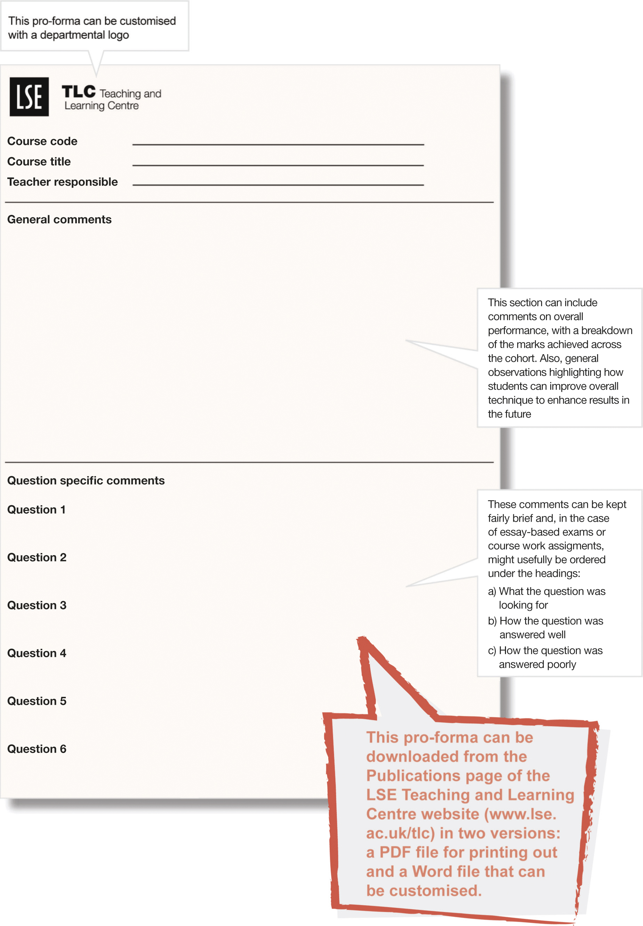

Additional benefits to be gained from doing collective examination feedback

Production of collective examination feedback should prove beneficial not just for students, but also for markers and for the course teaching team. For markers, the process will help (newer) colleagues to understand marking standards and be a useful part of improving marking consistency. For course teams, this overview of student examination performance may help clarify which parts of the course are well understood by students and which parts possibly need further development.

Another potential benefit could be in providing future students with more informed guidance on how to approach examinations. For example, this year the Teaching and Learning Centre is funding a project in Economic History which will give students access to some past (real) examination answers along with examiner commentary on the strengths/weaknesses of those answers and guidance as to how marks were awarded. Class teachers will also have access to some examples of student answers that they could use in running a peer marking task. Doing this once in the year can eliminate repeated office hour questions about exam marking and standards, as well as successfully preparing students for their revision.

Teaching and Learning Centre support for departments
If any department is unsure about how to approach this task, do feel free to contact us. We will work with you to run the process in the first year, and explore with you how you and your students can get the greatest benefit from the process.


Coming soon in the Feedback series
• Using technology for feedback
• Self-feedback and
peer-to-peer feedback
• Doing less better
Further reading
This booklet is available in electronic format and, on request, in
alternative formats. Please contact tlc@lse.ac.uk
The London School of Economics and Political Science is a School of the University of London. It is a charity and is
incorporated in England as a company limited by guarantee under the Companies Act (Reg No 70527).
Design: LSE Design Unit (www.lse.ac.uk/designunit).
Published by LSE Teaching and Learning Centre, May 2011
For more on the NUS’s Feedback Academy see
www.nus.org.uk/en/Campaigns/Higher-Education/Assessment-feedback-/

For further ideas on assessment at LSE see the following LSE Teaching and Learning Centre’s Notes of Guidance:
1: Broadening student assessment
3: Preparing examination papers and preparing students for examinations
4: Making best use of pro-forma for essay feedback
6: Giving feedback on oral presentations
7: Giving feedback on quantitative work
All Notes of Guidance are available at the Publications page of the LSE Teaching and Learning Centre website (www.lse.ac.uk/tlc).

