
Giving feedback on oral presentations

NOTES OF GUIDANCE 6

Welcome to the latest title in the Feedback series from LSE’s Teaching and Learning Centre. This note explores feedback on presentations and the development of oral communication skills for students. Effective communication skills are crucial for the development of students’ analytical and critical thinking while at university and for success in their future careers.

This note considers:
- how to support students in the design and delivery of presentations,
- how to effectively integrate presentations in class teaching, and
- how to provide feedback on both disciplinary content and oral communication skills.

The LSE context
Results from the 2010 National Student Survey under the ‘personal development’ category show that students at LSE are the least satisfied with this aspect of their studies compared with all other Russell Group universities. This highlights the need to enhance students’ oral presentation skills both within their disciplines and for life beyond academia. Presentations are an integral part of many courses across the School and thus provide an opportunity for developing oral communication skills as part of overall academic and personal development.

Giving feedback on oral presentations

What is the role of feedback in oral presentations?
It supports the student’s disciplinary learning
Feedback is an integral part of developing the student’s disciplinary identity. It demonstrates how a student’s argument and justification in their oral presentation can also inform their writing in the discipline.
- In what ways has the student’s presentation shown how they engage with disciplinary language and approaches?
- In what ways has the student presented a persuasive argument/case backed up with evidence?
- In what ways has the student’s presentation demonstrated that they can summarise and evaluate key concepts and apply them in the discipline?

It supports the student’s learning beyond the discipline
Feedback on the design and delivery of the presentation supports the student’s personal development in both oral and written communication skills.
- In what ways has the student’s presentation captured the audience’s attention?
- In what ways is the presentation logical and easy to follow?
- How have the visual aids added to or distracted from the presentation?
- How have their voice, clarity and timing contributed to the presentation?

 | Integrating student presentations into course and class design  There are a few key questions to consider when planning to include student presentations in sessions.  • What is the overall purpose of student presentations in relation to the development of both disciplinary and broader skills?  • How do presentations contribute to the students’ learning for the rest of the class session, essays, problem sheets and exams? | • What type of presentations are being used? For example, are they individual or group presentations? Are they summarising readings, opening up the subject or responding to a question? Is the intention for the student to be descriptive or does the presentation also need to include a deeper analysis and critique of the subject?  • How to ensure that feedback is provided in a timely fashion to enable students to respond to it in future assessments?
 | Preparing students for class presentations  • Discuss with students the overall purpose of student presentations both within the discipline and for their broader skills development.  • Ensure that their presentations link to the class and/or rest of the course.  • Consider timing and format. For instance, keeping the presentation short is useful so that it does not dominate the class session but acts as a way of structuring the class – placing it halfway through the session for 10 minutes, with 5 minutes for the presentation and 5 minutes for questions – and limiting the use of PowerPoint to 4 or 5 slides at most or one side of A4 of notes is a good discipline. | • Discuss the feedback criteria with the class and, where appropriate, develop a customised feedback sheet based on the pro-forma opposite (the Teaching and Learning Centre can work with you on this if useful).  • Offer them visual aid advice – good practice in using PowerPoint, preparing handouts for other students in the class, for instance.  • Suggest a meeting before the presentation. This can be useful in ensuring that the student has addressed the question and that the presentation is well integrated into the rest of the session.  • Let the student/s know how they will be receiving feedback (office hours, feedback sheet, Moodle, in the class, audio feedback) and what elements of the presentation they will be given feedback on.
 | Running class presentations  • Outline the structure of the session at the start, indicating when and how long the presentation will be and how it fits into the overall class plan. | • Clarify what the role of the rest of the class is during the presentation/s. Do they ask questions after the presentation? Do they give peer feedback on all or some aspects of the presentation to the student?

I provide individual oral feedback straight after class and a written email soon after – comments on structure, content, interaction with audience.
Anthropology lecturer

I provide generic and some individual feedback immediately after the presentation.
International Political Economy lecturer

The Government Department provides class teachers with feedback forms for both essays and presentations – both are formative feedback and are meant to provide students with information on how to improve their work next time around.
Government GTA

I give feedback on presentation outline prior to class.
European Institute lecturer

I ask the students to prepare and present a group presentation which is summatively assessed. Our feedback is typically formed of the following components: peer-review, end of session instant feedback from teachers, in-depth discussion among assessors (within about a week). These are then summarised and made available via Moodle.
Statistics lecturer

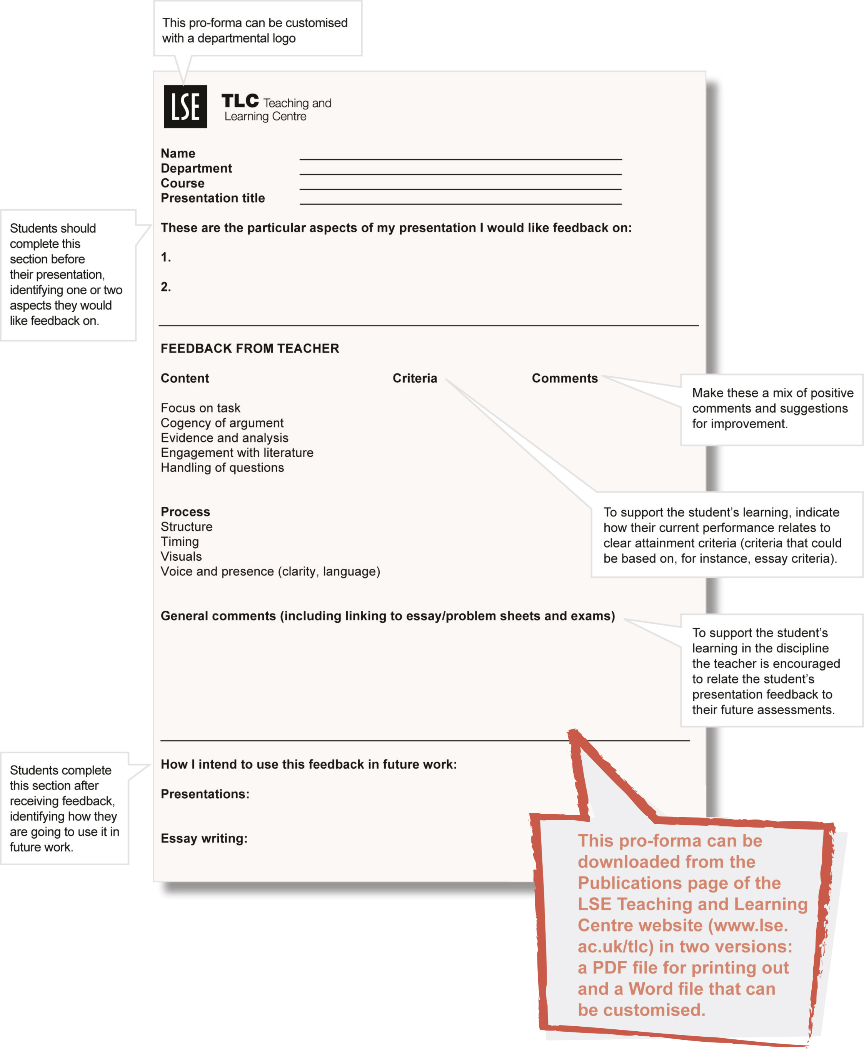
A sample pro-forma for oral presentation feedback

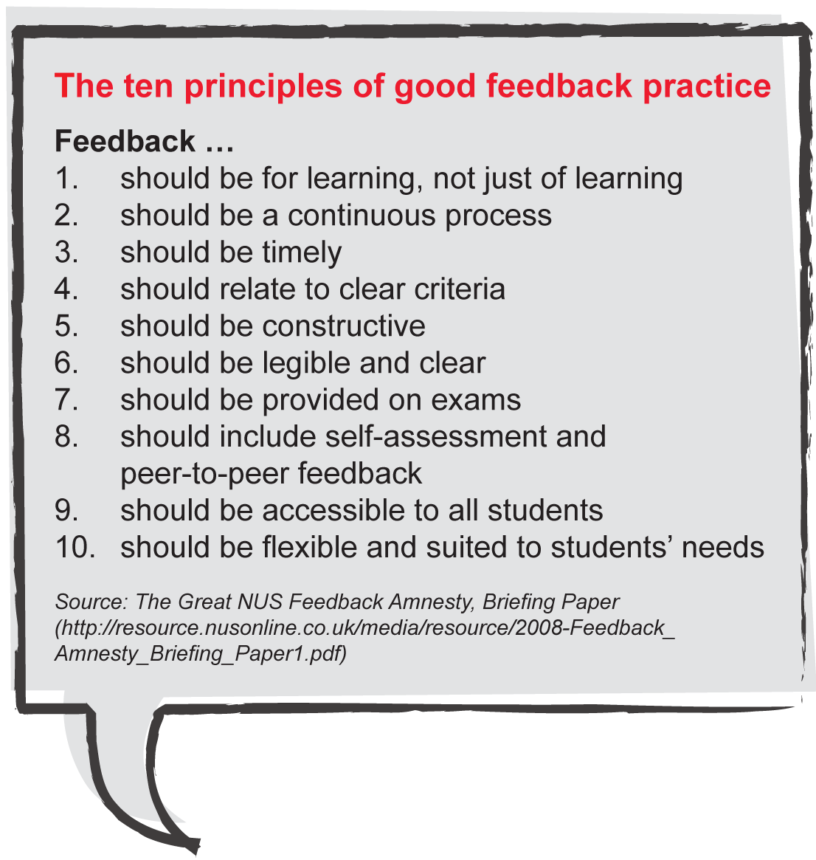
Using a pro-forma to give feedback on presentations (like the example on page 3) enables teachers to address many of the principles of good feedback practice identified in the NUS Feedback Amnesty, an extensive project exploring student expectations about feedback.

Further reading
For more on the NUS’s Feedback Academy see
www.nus.org.uk/en/Campaigns/Higher-Education/Assessment-feedback-/

For further ideas on presentations see the following online resources
http://moodle.lse.ac.uk/course/view.php?id=698
http://www.kent.ac.uk/careers/presentationskills.htm
http://www.llas.ac.uk/resources/mb/2722
http://skills.library.leeds.ac.uk/topic_presentation.php
http://www.lboro.ac.uk/library/skills/presentation.html
http://www.le.ac.uk/oerresources/ssds/presentationskills/index.htm
http://www.canberra.edu.au/studyskills/learning/oral

For LSE-specific guidance see the following LSE Teaching and Learning Centre’s Notes of Guidance
1: Broadening student assessment

3: Preparing examination papers and preparing students for examinations
4: Making best use of pro-forma for essay feedback
Coming soon in the Feedback series
• Using technology for feedback
• Self-feedback and peer-to-peer feedback
• Doing less better
5: Giving collective feedback on exams
All Notes of Guidance are available at available at the Publications page of the LSE Teaching and Learning Centre website (www.lse.ac.uk/tlc).
This booklet is available in electronic format and, on request, in
alternative formats. Please contact tlc@lse.ac.uk
The London School of Economics and Political Science is a School of the University of London. It is a charity and is
incorporated in England as a company limited by guarantee under the Companies Act (Reg No 70527).
Design: LSE Design Unit (www.lse.ac.uk/designunit).
Published by LSE Teaching and Learning Centre, May 2011

