
Giving feedback on quantitative work

NOTES OF GUIDANCE 7

Welcome to the latest title in the Feedback series from LSE’s Teaching and Learning Centre. The series takes as its starting point a key principle set out in the recent Academic Board paper on feedback – that it should be a dialogue between student and teacher – and reflects the ten principles proposed by the National Union of Students’ Feedback Amnesty, an extensive project exploring student expectations about feedback.

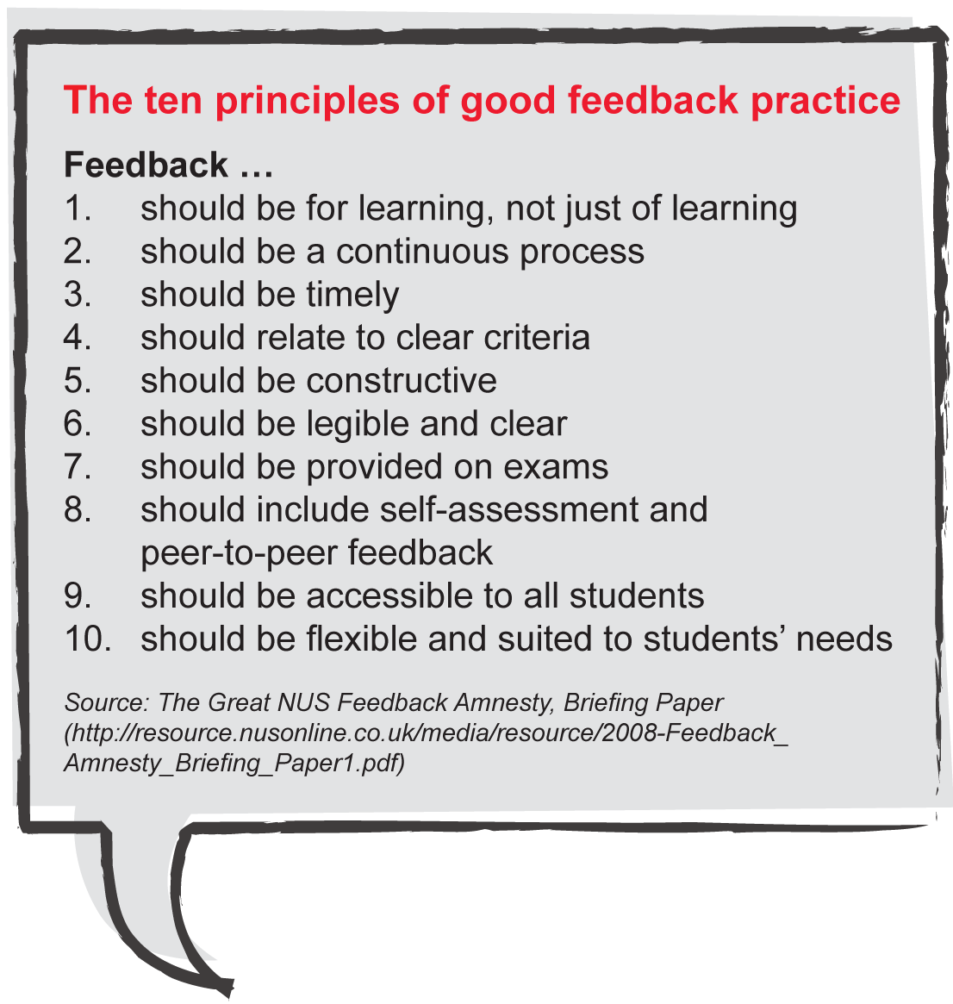
This title explores feedback on ‘quantitative’ courses, of which a wide-ranging and diverse collection is taught at LSE.

That striking diversity means that different forms of feedback are likely to be appropriate for different courses, and we hope that the varied ideas in these notes include suggestions relevant to most of LSE’s quantitative modules.

Despite their variety they are unified by two themes:
- attempting to take into account distinctive features of students’ needs from quantitative courses;
- discussing how feedback across the whole of a course’s provision can fit together to help to meet those needs.

Assessment criteria for quantitative work
An important precursor to giving and receiving feedback effectively is students’ knowledge about the criteria for assessment, as they apply to both formative work and formal assessment. Many of the criteria will be determined by the discipline and the level of the course within it, and are hence beyond the scope of this note, but some issues are common to most quantitative courses (or even other courses), and are worth mentioning here.

- It is common on quantitative courses to have a system in which (in effect) there are ‘method’ marks and ‘accuracy’ marks (perhaps rarely supplemented by the odd ‘presentation’ mark, say for an elegant  explanation). It is often the case in such systems that if a student attempts to use an appropriate method but makes some relatively minor error in her/his calculations, most of the marks available are still awarded: students need to know if such a system is being followed.
- Most quantitative courses involve highly cumulative elements, so that early on the exercises which students do are often easier or more elementary than the ones they will face at the assessment stage, and it should be made clear to students, firstly, that they will meet this pattern, and, secondly, that the final assessment criteria are (or are not) stricter than those applicable to early homeworks.
- Exam rubrics - for instance, ‘the best four marks (out of more questions) will count towards your grade’ or ‘your best three marks from each of section A and section B will count towards your grade’ - should be clearly explained to students. If the right rubric is not clear at the start of the most recent past exam, or if it has changed, then the current policy should be drawn to students’ attention.
- It is good practice on an exam paper to show the marks for part questions as well as for a question as a whole, and on the solution to show a more detailed breakdown (primarily for markers, but also for students in subsequent years).

Despite these comments, it has to be recognised that while assessment criteria apply to work submitted, they do not in and of themselves address the magic question about quantitative exercise sets: how to acquire the skills to recognise what situation a problem is describing, what the student should try to do about it, and what techniques or strategies they will need to do it. For a note about how feedback might help to tackle these, see ‘Feedback on formative homeworks’ below.

Feedback and assessment at the formative stage
On the typical quantitative course, both undergraduate and postgraduate, the formative stage involves students doing regular exercises as ‘homework’ before each class. Different departments deal with these formative materials in different ways - sometimes the students’ work is handed in and marked by the class teacher before each session, which provides a basis for planning teaching in the subsequent class; sometimes students are expected to do the homework in advance of each class, but are required to hand it in for marking only in certain weeks; sometimes students complete online quizzes – but whatever the arrangements on a given course, there is an important flow:

homework (or summary information) → teacher
→ feedback for students in class

which complements - and should be integrated with – written and other forms of feedback made available to students.

Feedback on formative homeworks
The purpose of students doing homeworks (and of any feedback they get) is not to show them the ‘answers’ to the particular questions they have tackled. It is to help them acquire the three distinguishing skills involved in quantitative courses, namely recognising:
- what situation the question is describing,
- what the question wants them to do about that situation,
- what techniques/strategies they will need to do it.
That is, from doing and getting feedback on a question students should learn to analyse and to tackle the next question of broadly the same type.

Following from this, and whether or not students’ homeworks have been marked before class, there are several essentials and one suggestion for fruitful feedback:

Solutions
Solutions can be made available either during the session or afterwards, depending on the course. There are several obvious advantages and difficulties in their use:
- They can help ensure sufficient uniformity of guidance to students across a diverse body of class teachers.
- They can cover the full range of questions from an exercise set, allowing class teachers to select and prioritise what is discussed in class.
- They should guide class teachers’ marking (when that is relevant) and can help class teachers choose how to discuss topics in session.
- They are there to look back at after a class is over, including during revision.
- They can be written so as to include ‘tips’ (or other remarks) which students would be well advised to take forward for use in similar future questions – so they ought to be far more than narrowly numerical or algebraic ‘answers’.
- It turns out that, on some courses, electronic copies of solutions for previous years’ homeworks are available at various sites on the internet (for example, on the Wayback Machine), and expedients such as using different question sets in successive years will not overcome the ease with which modern search engines can track down such items. Departments report various precautionary steps to deal with this problem, and students who copy past solutions for formative homeworks are sabotaging their own studies, but further attention to this issue seems inevitable.

Discussions in class
Techniques such as student presentations tend to play a smaller part in ‘quantitative’ classes than in groups which are run more in the style of a seminar discussion, but it is important to run sessions so that students feel free to ask questions of what they are told in the class and/or which are raised by the work the students have done.

What is appropriate for each class and session can be identified in most detail if students’ work has been marked, but quizzes and the expectations of lecturers and teachers are also highly relevant.
Comments on students’ scripts
These are usually appropriate when the students’ work has been marked for return to them, and have some obvious advantages:
- They can (briefly) explain a student’s errors (or flag things they have done well – praise can be important for a student’s morale!) so that they can readily match up a remark and the part of their text to which it refers.
- They enable illustrations to be picked out of the blue. For instance, a comment might read ‘t-distribution here, because of small sample size’, or ‘ingenious alternative proof – compare/contrast with solution’.
Class teachers’ available time for marking is, however, limited, and it may well be appropriate, in the case of an issue which crops up in scripts from many students in a group, to decide only to deal with that point in the session, not to write out the same comment many times.

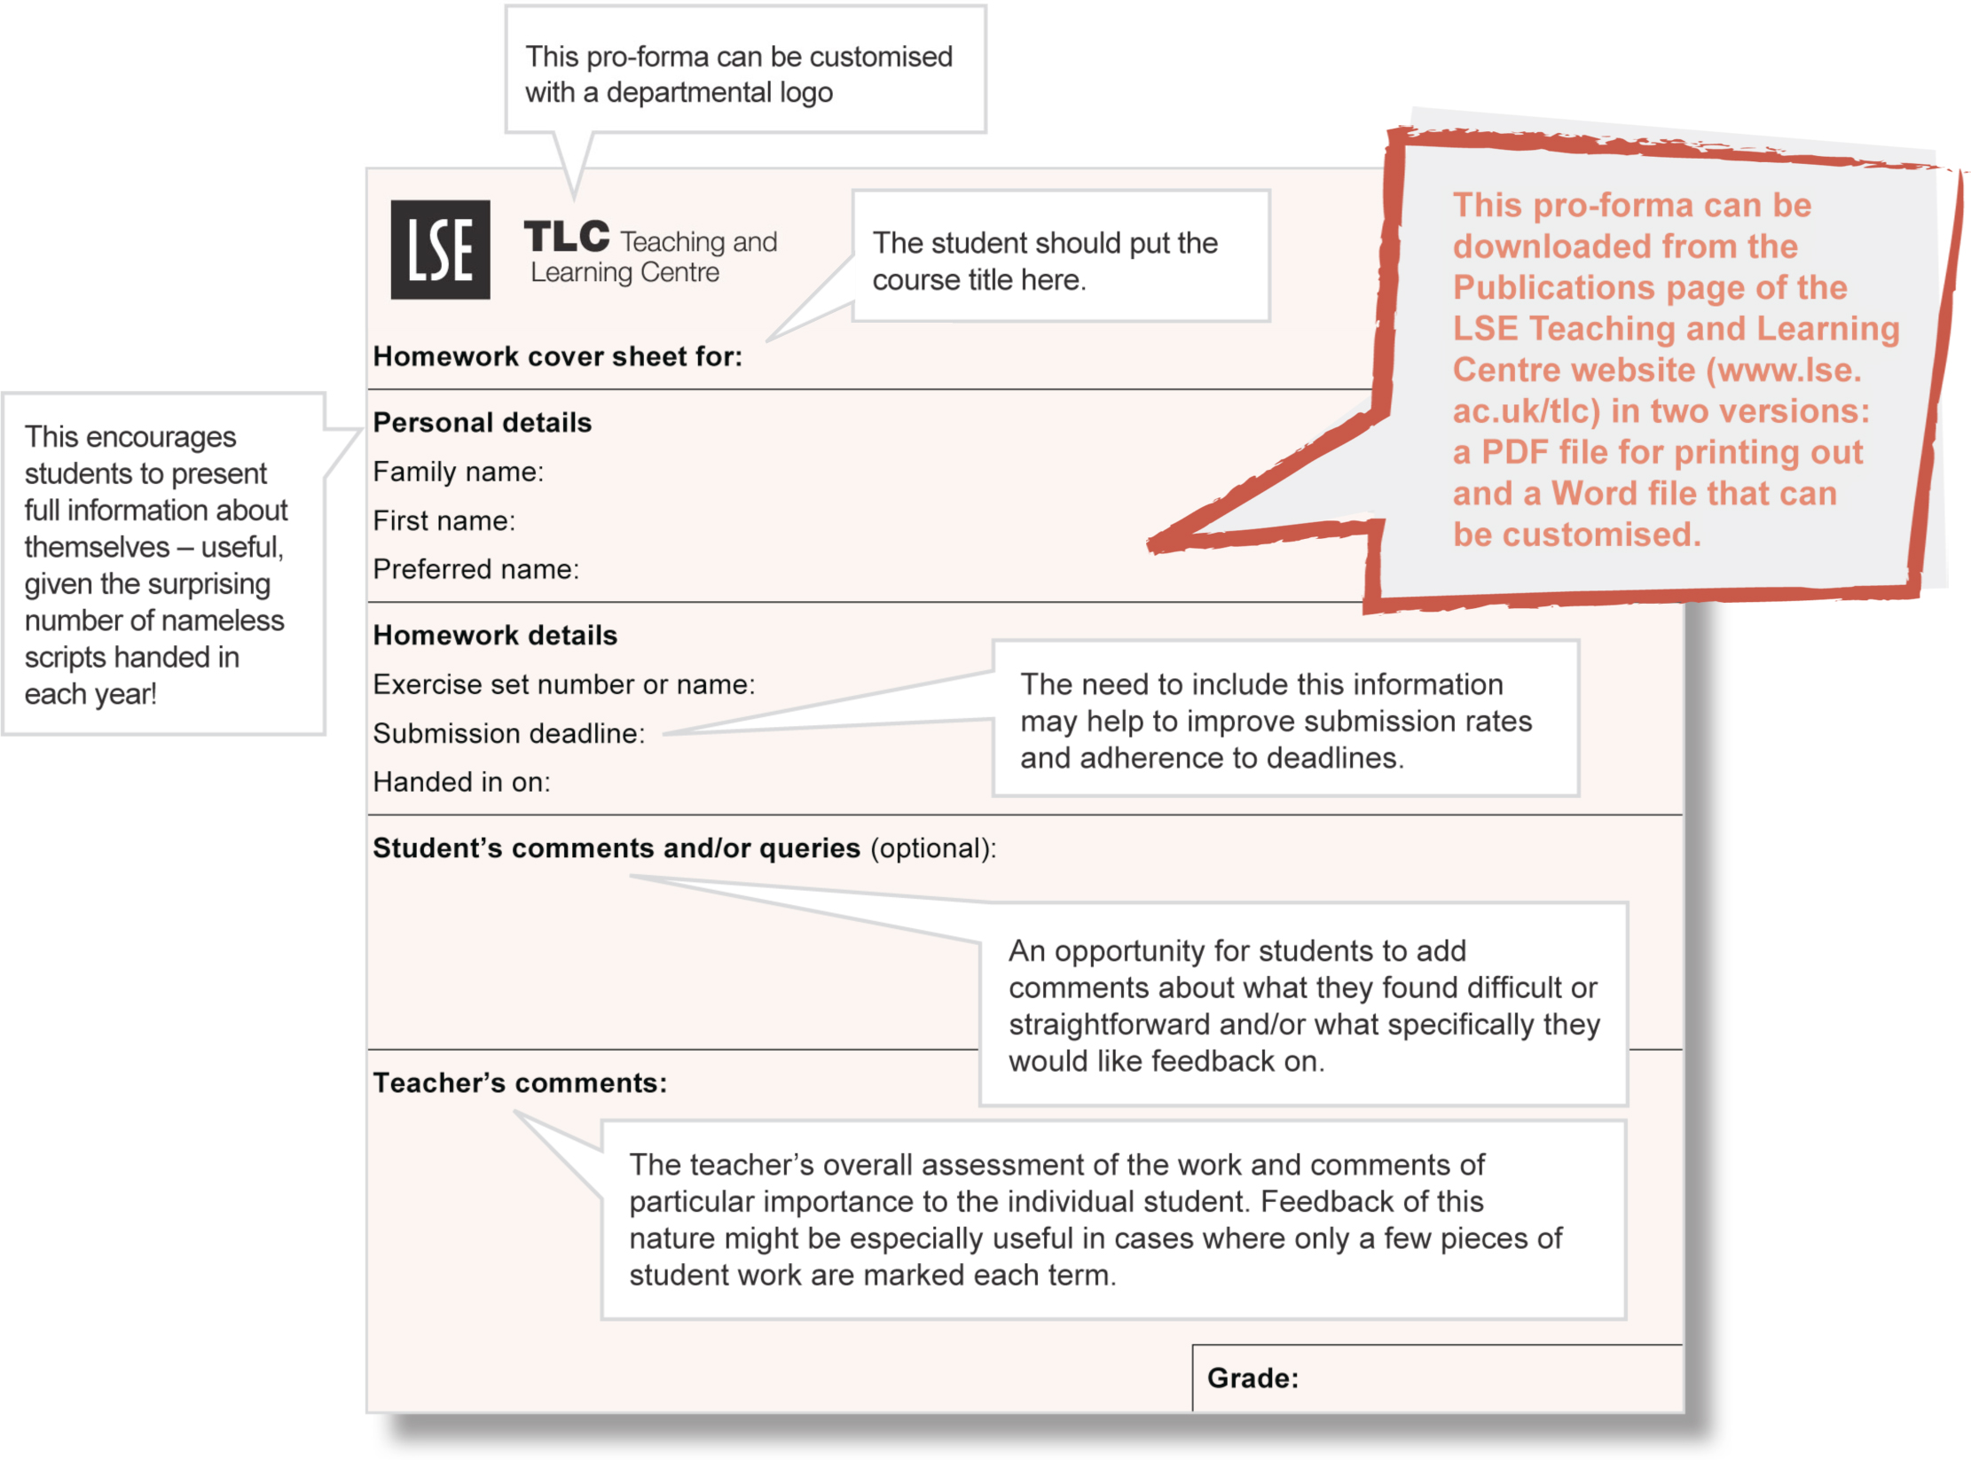
Feedback pro-formas
These can also be useful, and a simple example (adapted from one devised by a class teacher in Mathematics and Statistics) is shown below. As will be obvious, the pro-forma is designed to be attached to a student’s work, with the top section completed by the student before handing the work in.

Set against the possible benefits annotated are the fact that many comments on students’ work are usually best made at the point on their scripts with which the comment deals, and that using pro-formas as the only, or main, source of feedback might limit students’ options to look at solutions.

Other opportunities to give feedback
Extra optional sessions provide an opportunity for students to ask questions about topics they do not grasp, and hence to make better efforts at doing the corresponding questions in their homework sets. Such sessions, run already in some LSE courses, seem very popular with students.
Office hours provide another opportunity for students to discuss topics and get feedback about them, both before homeworks are due in and when students are looking through homework (or exam) solutions. They are typically an under-used resource, especially during Michaelmas Term, and it may be worth examining whether their availability could be ‘profiled’ so that there were fewer when demand is likely to be low, and more when it is likely to be higher.
Moodle discussion forums can serve similar functions to those just mentioned, but (on large courses) across the whole student body.

A note on feedback for exam preparation and exam solutions
While assessment at LSE is not always by examination, exams are nevertheless a key element of many LSE courses. Exams for some quantitative courses at LSE are ‘open book’, and departmental policy is not to provide solutions. Except in such cases, it is generally desirable to make available to students both the papers and the solutions to recent past exams, with the following provisos.

- Exam solutions often contain initial errors which creep past the drafting stage and are identified when the solutions are being used for marking. When this happens, it is good practice to make available a corrected version of the solution for teaching purposes in future years.
- It should be made clear to students that an exam’s ‘style’ evolves and that its syllabus tends to change as time passes, so that older exams may not always be a good guide to future exams. (Some departments restrict the availability of past solutions for just this reason, but it is worth noting that, as a source of practice questions for a specific topic (Cobb-Douglas production functions or matrix methods, say), even papers from years ago can frequently be very useful.)
This note is available in electronic format and, on request, in
alternative formats. Please contact tlc@lse.ac.uk
The London School of Economics and Political Science is a School of the University of London. It is a charity and is
incorporated in England as a company limited by guarantee under the Companies Act (Reg No 70527).
Design: LSE Design Unit (www.lse.ac.uk/designunit).
Published by LSE Teaching and Learning Centre, May 2011
Resources
For students’ mathematical skills

It is not uncommon for students on quantitative courses that are not in themselves mathematical – some economics and many statistics courses, for instance – to be lacking in the necessary mathematical and manipulative skills. There is no easy solution to the problem, but there are some useful resources:
- Section 8 of the Teaching and Learning Centre’s Moodle site Learning World – especially the subsection entitled ‘Dr Tony Whelan’s core mathematical handouts’ – includes materials for basic numeracy (Very Basic Maths) and elements of algebra, calculus and introductory matrix methods.
- Course materials on introductory courses from the Mathematics Department, notably MA107 Quantitative Methods (Mathematics) (which requires a maths A-level) or MA110 Basic Quantitative Methods (some of which duplicates a maths A-level), may be useful.
- The Teaching and Learning Centre offers various forms of one-to-one and one-to-group support for quantitative work. Students can call 020 7852 3627 or email studentsupport@lse.ac.uk to book.

Further reading

For more on the NUS’s Feedback Academy see
www.nus.org.uk/en/Campaigns/Higher-Education/Assessment-feedback-/

For further ideas on assessment at LSE see the following Teaching and Learning Centre’s Notes of Guidance
1: Broadening student assessment
3: Preparing examination papers and preparing students for examinations

4: Making best use of pro-forma for essay feedback
5: Giving collective feedback on exams
6: Giving feedback on oral presentations

All Notes of Guidance are available at the Publications page of the LSE Teaching and Learning Centre website (www.lse.ac.uk/tlc).
Coming soon in the Feedback series
• Using technology for feedback
• Doing less better
• Self-feedback and
peer-to-peer feedback

