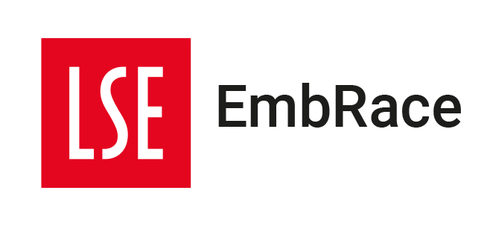
RISE Coaching Circle

Programme Details

RISE aims to address the unique challenges faced by Black and Global Majority staff, promote their personal and professional development.

The RISE Coaching Circle provides Staff will be empowered to feel greater confidence, navigate the workplace, overcome barriers unique to their lived experiences, and achieve their full potential.

Participants will finish the coaching programme:

- Increased self-confidence, self-efficacy, and self-awareness.
- Enhanced leadership skills and career progression opportunities.
- Improved resilience and ability to navigate workplace challenges.
- Development of strategies for managing unconscious bias and microaggressions.
- Greater job satisfaction and engagement.

Dates of the programme:

- Group Coaching Program All Day Residential – TBC
- Module 1: Wednesday 24 April, 1.00pm –3.00 pm
- Module 2: Friday 10 May, 1.00pm –3.00 pm
- Module 3: Friday 17 May, 1.00pm –3.00 pm
- Module 4: Friday 31 May, 1.00pm –3.00 pm
- Post-Course Social - TBC

To apply, please complete and return the form below to Embrace@lse.ac.uk by Monday 8 April.

RISE Coaching Circle Application Form

Your details
First name: |  |  |  | Surname:
Division/
Department
Salary Band: |  |  |  | Role:
Email:
This application form is designed to support the selection process in the event of a competitive process being required. The following selection criteria will be considered:
- A selection of candidates from different bands (4-6)
- Readiness to take the next steps in your professional progression
- Motivation to realise and achieve career goals
- Willingness to contribute to group dynamic

We will also consider if this is the right programme for the individual, what alternatives may be available and has the applicant had any recent training.

Please complete the questions below if you are interested in participating in the RISE Coaching Circle

1. Why are you interested in participating in the RISE Coaching Circle?
2. How will participating in the RISE Coaching Circle propel you into your next stage in your career? (Consider your goals around influence and impact)

3. How will you apply the learning gained from the programme to enhance your role within your Division/Department? (Please include what outcomes you expect for your Division/Department)

Learning agreement

RISE Coaching Circle participants agree to the following conditions:

1. The programme is a safe and brave environment.

2. Participants agree to fully engage in each of the sessions and tasks, dedicating time to reflect on what they have learnt in each session.

3. Participants should make every effort to attend all sessions (dates listed on page 1) in order to receive their certificate.

4. To advise Embrace as soon as practical of any problem that may impact on the participant’s successful completion of the course.

Participant Signature:……………………………………………… Date:…………………………

Line Manager’s Signature:……………………………………………… Date:…………………………

